TEJ101 Engineering
Activity 16:  Networking Technology | No. of Classes: 2 | Students Name:

Objectives: In this activity, students will:

- investigate various networking technologies
- become familiar with various terms associated with networking.
- Explore the advantages and disadvantages of wired and wireless networks



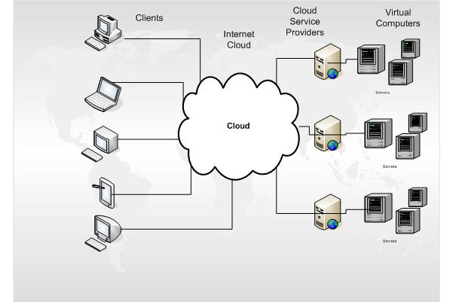

Part 1: Home Networking Concepts
One of the most common household digital devices now found in homes are the router and the modem. Routers connect computers and peripherals to one another, either through Cat 5e Ethernet cables or through a wireless connection. The modem connects your router to the internet. Once you connect your router to the modem, you're then able to share that internet connection with all of the computers on your network. Some modems will come with routers built-in, but this isn't always the case.
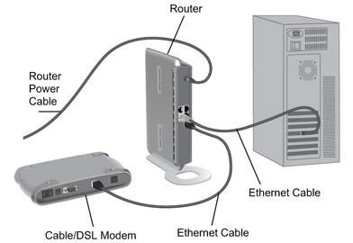
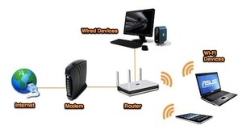
Devices that can connect to your router include: computers; tablets; smartphones; DVRs; game systems, printers and more. These are referred to as ‘clients’. Each client on the network is given an IP address, which helps your router direct traffic. Clients within the network get a local IP address, while your modem gets a global IP address. Global IP addresses are like street addresses, while local IP addresses are like apartment numbers: one lets you find the building in relation to the rest of the world, while the other lets you find the specific location within the complex. These addresses make sure the right information from the outside world gets to the right computer on your network.

Wired vs Wireless
Computers that don’t move around generally are hardwired to the internet since wired connections are fast, reliable, and cheap. They're far from ideal for devices you pick up and move around, though, like laptops, so for those a wireless connection (commonly known as Wi-Fi) is generally used. Wi-Fi is more than adequate for simple web browsing, though wired connections are ideal if you're transferring big files, gaming, video chatting, or streaming video. Since wireless routers allow for both wired and wireless connections, you can wire up when necessary, and connect over Wi-Fi everywhere else, just as you do at our school.

Wireless Throughput
“Throughput” is the speed at which a router can transfer data. The transfer speed of your wireless connection is dependent on the wireless standard it uses. The most common standards today are 802.11g and 802.11n (also known as "wireless G" and "wireless N", respectively). Wireless N is faster than wireless G, though routers that support wireless N are also more expensive. Most new devices—like smartphones and laptops—support the faster wireless N.
Your router isn't the only thing that determines wireless speed: you also need the correct kind of wireless card in your computer. If you have an older laptop, it might have an older wireless G card inside, meaning it can't take advantage of wireless N speeds. If you have a mix of N- and G-capable computers, you can turn on a wireless N feature called "mixed mode", which will let you use both on the same network. You'll get faster speeds on the wireless N clients and slower speeds on the wireless G clients. (Some claim, however, that running both N and G devices on the same network can lower speeds across the network, even between a wireless N router and wireless N computer.) However, if you want the fastest possible speeds, you'll probably want all wireless N devices on that network. It should also be noted that this technology is constantly changing and new standards will continue to increase speed and bandwidth.

Wired Throughput
The wired half of your router will come in one of two speeds: 10/100 Mbps and 10/100/1000 Mbps (also known as "gigabit"). 10/100 routers are cheaper, but won't transfer data between computers as quickly as gigabit routers will. If you're only using your router to connect to the internet, 10/100 is fine, since your internet connection is probably slower than 100Mbps, meaning you wouldn't be able to actually take advantage of the router's full speed. If you're transferring data between computers, however, you'll want to go with a gigabit router, since it'll transfer that data much faster than a 10/100 model.

Range
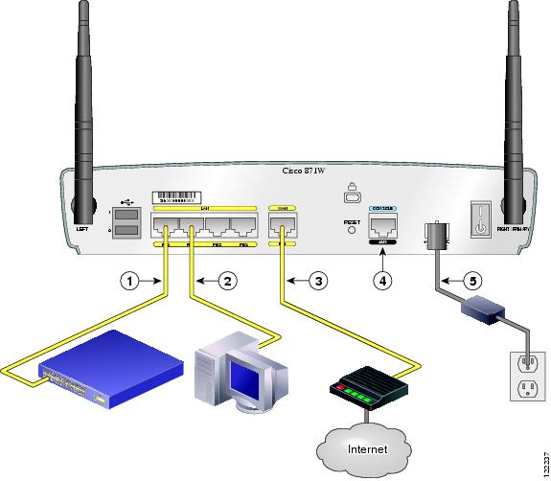
Wireless routers can only reach so far. If you have a big house and have the router on one side, you might not be able to access the network from the other side of the house. Your range, like your speed, is determined by the wireless standard you use. Wireless N has a longer range than wireless G, so if range is important you'll want to use wireless N.
Further, there are many other ways to connect to your network from afar. Wireless extenders (also called wireless repeaters) are products you can buy that do exactly what they say—extend your network further. Alternatively, you can buy a powerline adapter, which lets you use your home's electrical wiring to hook a faraway device up to your router with an Ethernet cable (and thus get a faster connection than wireless would allow for).

Number of Ports

Routers have two types of ports in the back: LAN ports and WAN ports. Your WAN port hooks up to your modem (which, again, is what connects to the internet), while the LAN ports hook up to your computers and other clients. Most routers have one WAN port, but you'll need as many LAN ports as you have wired devices. If you have more wired devices than can fit on a router, you can plug them all in using a wired switch. A switch is like a power strip for your router: it lets you plug in more devices than the router originally allowed.

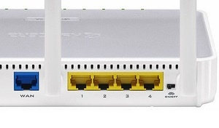

Number of Bands
Wireless routers broadcast on a radio band, and many new wireless N routers can broadcast on two bands. These are called, appropriately, dual band routers. Older routers and computers operate on a 2.4Ghz band only, while dual-band routers allow for both the 2.4Ghz band and a 5Ghz band. The 5Ghz band is great because it has less interference, since many other devices—from other networks to Bluetooth to cordless phones to microwaves—operate on the 2.4Ghz band.
The main downside of the 5Ghz band is that, since it uses a higher frequency, it isn't as good at penetrating walls. As such, if you run your router in 5Ghz mode, you might have a shorter range than if you ran it in 2.4Ghz mode. In addition, some older devices don't support 5Ghz. The solution to this problem is to use a simultaneous dual-band router, which can broadcast on both bands at once.

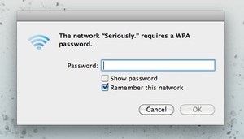
Wireless Security

You should always protect your wireless network with a password. WPA2 is currently the most secure type of wireless encryption, so make sure you use WPA2 if you can. Some old wireless devices won't support WPA, in which case you'll have use the less secure WEP instead. Basically every device made in the last four years support WPA2 encryption.
If you're planning to use your router for a small business, you might want to look for a router with the "guest network" feature, which allows other people to access the internet without giving them full access to your computers and sensitive data.

Type of Wireless Networks
The wireless industry uses many confusing and complex terms and acronyms. Here are three of the major ones, and brief description:

WiFi
WiFi stands for “Wireless Fidelity” – just like HiFi stands for “High Fidelity . WiFi is a LAN (local area network) standard that extends home and business computer networks onto the wireless medium of radio waves. The WiFi standards define how those wifi devices should communicate with each other. The standards are required so that various devices (iPhones, computers, Blackberry’s, etc) can interoperate with each other and have a constructive “conversation”.
WiFi provides aggregate user data speeds from 2Mbps (802.11b) up to around 150Mbps (802.11n). Typical speeds are around 15Mbps (good for most “normal” uses). Latency (packet delay) averages around 10ms with no load (very good). Max distance is typically several hundred feet with standard hardware, although large antennas and special software can enable links over many miles.

WiMAX
WiMAX stands for “Worldwide Interoperability for Microwave Access” and means radio frequencies above 1GHz.
WiMAX is a WAN (wide area network) standard that is designed to operate in a cell-phone type of network but provide relatively high-speed data access. Like WiFi, it is a networking standard (actually several) that’s designed to allow various devices to interoperate, however unlike WiFi it’s designed to operate over large distances outdoors to support a service provider using a WiMAX network to serve many individual customers. Usually WiMAX is used to provide internet access to end-users as opposed to LAN-style connectivity.
WiMAX speeds depend on the size of the RF spectrum used for the connection. Typical speeds are around 7Mbps download and 2Mbps upload, although newer versions of the standards will increase speeds as networks are upgraded. Latency is typically around 40ms (in contrast with 300+ms for 3G cellular networks), which is a respectable value for general internet use.

LTE
LTE stands for “3GPP Long Term Evolution” – 3GPP is a telecom partnership that oversees things like GSM (the cell phone standard). LTE is basically the “next step” for the cell phone companies.
Since LTE is a cell-phone style network standard you can imagine that it’s not used for LAN connectivity, but for internet access (and voice). LTE provides a much more data-focused network than traditional cell networks have so far. LTE and WiMAX use similar techniques to provide higher speeds and better range, but they do it in different ways. It’s kind of like the Mac vs PC argument – they both get the job done, but with different methods and styles.
LTE performance on a loaded network is still in the “TBD” category, but since the underlying technologies and available spectrum are well known we can take an educated guess. Speeds will likely fall around 10Mbps down and 3Mbps up (in the US) to start. Latency should be around 30ms.

Which is Best?
First you need to decide if you’re looking for LAN connectivity or WAN (internet) connectivity. If you want LAN functionality then you need WiFi. For mobile internet functionality WiMAX and LTE can both be good options. Both of these standards are considered “4G” connectivity. If you want voice service on the same device as your data service then LTE is the best option because there will quickly be many popular handsets with LTE support whereas WiMAX support remains rather sparse on handsets.
For simple mobile data service LTE appears to be the standard that everyone is moving to, so long-term, devices that use LTE will probably be a better investment. If you need connectivity right now then you’ll probably need to go with WiMAX since devices are available and coverage is widespread.
Networking Terms Glossary:

Bandwidth (Network Bandwidth)
As compared to Network Speed, bandwidth can be defined as the throughput of your connection to the Internet. Measured in Kbps or Mbps (1.4Mbps for instance).

Broadband
A term loosely used to describe any of several high-speed methods of delivering internet access to the home. Contrasted with dial-up access, which has a maximum speed of 5Kbps, broadband in the U.S. is generally rated at a speed of between 64Kbps and 768Kbpbs.

Cable Modem
A cable modem is a type of modem that provides bi-directional data communication via radio frequency channels on a cable television (CATV) infrastructure. Cable modem speeds vary widely. While cable modem technology can theoretically support up to about 30 Mbps, most providers offer service with between 1 Mbps and 6 Mbps bandwidth for downloads, and between 128 Kbps and 768 Kbps for uploads.

CAT-5 (or CAT5) Category 5.
Cat-5 refers to a physical cabling standard, sometimes called Ethernet cable. It is a current industry standard for network and telephone wiring. Cat-5 cable is unshielded wire containing four pairs of 24- gauge twisted copper pairs, terminating in an RJ-45 jack

Ethernet
A type of network technology for local area networks; coaxial cable carries radio frequency signals between computers. The name comes from the physical concept of the “ether”. It defines a number of wiring and signaling standards. Ethernet technology describes the hard wires and connections that exist in our home network.
Firewall
A part of a PC or network that acts as a barrier for unwanted or unauthorized data. A Firewall can be implemented in hardware or software and is usually built into the network Router.

IP Address - Internet Protocol address.
The address of a computer attached to a TCP/IP network. Every PC and Server must have a unique IP address. PCs have either a permanent address or one that is dynamically assigned to them by a server. IP addresses are written as four sets of numbers separated by periods; for example, 122.21.55.6.

LAN - Local Area Network.
A local computer network for communication between computers; especially a network connecting computers and word processors and other electronic office or home equipment to create a communication system.

Modem
From a combination of Modulater and Demodulater. A Modem is a device that modulates an analog carrier signal to encode digital information, and also demodulates such a carrier signal to decode the transmitted information.

Router
A router is a device that forwards data along networks. A router is connected to at least two seperate networks, commonly two LANs (Local Area Network) or WANs (Wide Area Network) or a LAN and its ISP’s network. Routers are located at gateways, the places where two or more networks connect, and are the critical device that keeps data flowing between networks and keeps the networks connected to the Internet.

Server
A server is any combination of hardware or software designed to provide services to clients. When used alone, the term typically refers to a computer which may be running a server operating system, but is commonly used to refer to any software or dedicated hardware capable of providing services


Canadian Engineers build Space station Robot:
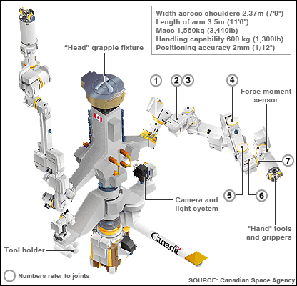
Canadian engineers have made substantial contributions to the International
Space Station (ISS) Operation, through the Mobile Servicing System (MSS). It consists of three robotic elements that can work together or independently.

The mobile base is the Canadarm2, a moveable work platform that was installed on the ISS in 2001 with the help of Canadian astronaut Chris Hadfield,
educated in mechanical engineering. In 2008, Canada built and added to the
ISS a sophisticated two-armed robot, commonly called Dextre, or the Special
Purpose Dexterous Manipulator.

Dextre’s 3.35-metre arms were flown to the station where the astronauts were
able to pin Dextre’s arms on his body and outfit him with a tool caddy, television
cameras and other accessories. Dextre the handyman was ready for the
space walk. Dextre can remove and replace small components on the station’s
exterior that require precise handling. It is equipped with specialized grippers,
built-in socket wrenches, four robotic tools, video equipment, lights, umbilical
connectors to provide power and data connectivity, and a stowage platform.
There are many exciting details about the Canadian ISS program on the Web.
Look up the NASA or Canadian Space Agency websites for more information
at http://www.asc-csa.gc.ca/eng/iss/dextre/default.asp

