TEJ101 Computer Engineering
Name: | Unit 2 Activity 11 – Computer Basics  Number of classes: 1

Background:

Today, computers are used in almost every aspect of our lives…you know that because you’ve seen their use in car engines; in your homes; the video games you play; in the watches you wear; in the telephones you use; at school; at work; in government buildings; in businesses; just about everywhere! However, there is another message in this for you and that is engineering and IT are the fastest growing segments of our economy, and that growth promises to continue well into your future. Are you planning now for a career in these areas? Are you taking the math, science, engineering and technology courses at BR that prepare you for those careers? Do you know what nano-engineering is, or how about mechatronics? In this unit you will be getting familiar with all of these careers and more. It’s time to start the journey!

This unit will introduce you to the various fields of Computer Science and Engineering. You will begin by exploring computer hardware and software and then investigating career trends and exploring educational programs that lead to a variety of computer related careers.

Objectives: In this activity, you will:

- Become familiar with basic computer terminology;
- Distinguish the difference between hardware and software;
- Understand the role of operating systems; and
- Develop an understanding of the various acronyms and terms associated with quantities of bits.


Do you know the name of this robot? Make sure you colour her!

Part 1: Computers Basics

For novice computer users, the computer aisles at an electronics store can be quite a mystery, not to mention overwhelming. However, computers really aren't that mysterious. All types of computers consist of two basic parts: hardware and software.

Hardware is any part of your computer that has a physical structure, such as the computer monitor or keyboard.

Software is any set of instructions that tells the hardware what to do. It is what guides the hardware and tells it how to accomplish each task. Some examples of software are web browsers, games, and word processors such as Microsoft Word.

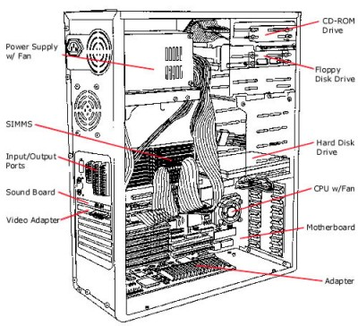

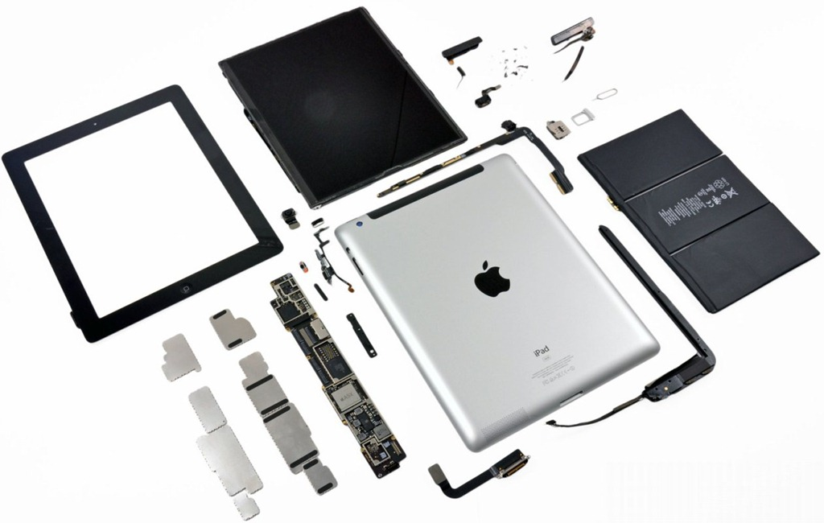

Tower computer components vs iPad 3

The first electronic computer, the Electronic Numerical Integrator and Computer (ENIAC), (see figure below) was developed in 1946. It took up 1,800 square feet and weighed 30 tons.(see figure below)
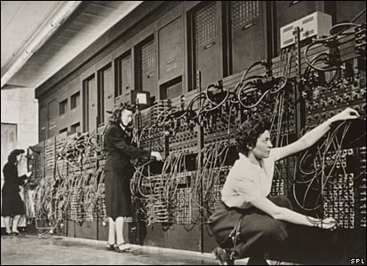

Part 2: Hardware:
Hardware is electronic equipment that is controlled by a set of instructions called software. Both hardware and software have a variety of subcategories. We will begin with hardware.
Computers, robots, and mobile devices all have similar hardware. Below I have identified the 5 pieces of hardware that are found in these devices.
1. The Processor:
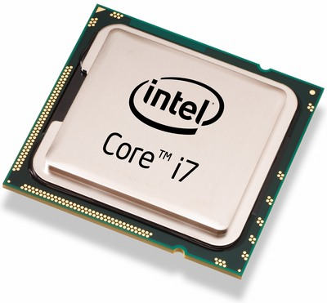
This is a specialized integrated circuit that accepts certain electronic inputs and, through a series of logic circuits and produces measurable computational outputs. There are two companies (Intel Inc. and AMD Inc.) who manufacture the majority of today's processors used in desktop and laptop computers. Many mobile devices now use the ARM processor. iPhones use A4 and A5 processors.

Processors are generally defined by their speed—in megahertz (MHz—millions of cycles per second) or in gigahertz (GHz—billions of cycles per second). The speed relates to the number of operations they can perform in one second. Higher value means faster performance and greater cost. Many processors still have 32 bit bus architecture, but the 64 bit bus architecture is becoming more and more common. A 64 bit processor can deal with twice as much data at the same time that the 32 bit processor can.
It is becoming more common for processors to have multiple cores. This means that there are two (dual) or four (quad) processors on a single chip. This really helps when you multitask a lot, e.g., checking email, browsing the web, looking at photos, and listening to music all at the same time.

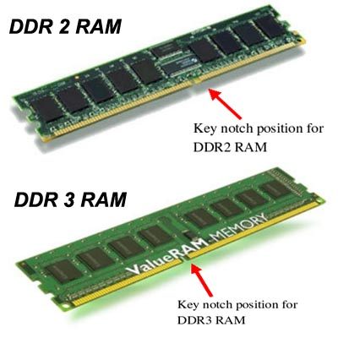
2. Working Memory – RAM
The main working memory in a computer is called random access memory or RAM. It stores information in a computer chip. The processor uses this memory to run programs and store information. The computer can access data in RAM much faster than data on your hard disk.

The main working memory in a computer is called random access memory or RAM. It stores information in a computer chip. The processor uses this memory to run programs and store information. The computer can access data in RAM much faster than data on your hard disk. RAM is measured in bytes, and in general, most computers now contain 4 or more gigabytes (GB) of RAM.

3. Permanent Storage - The Hard Drive
Hard drives store information on magnetized platters that spin rapidly. Information is stored and retrieved by a collection of arms that swing back and forth across the surfaces of the platters touching down periodically to read from or write to the platters. These devices fall into the category of “secondary storage" because the CPU does not have direct access to the information. Typically, information from the HDD must be loaded into RAM before being processed by the CPU. Reading and writing information from HDD's is slower than RAM.

As prices continue to drop, newer flash-based solid-state drives (SSDs) have become viable options for handling your computers primary storage requirements. Typical SSDs have 32GB of memory, enough to do more than satisfy basic storage needs--making them competitive with 1.8-inch hard-disk drives, which range in capacity from 500GB to 1000GB.
4. Motherboard

The motherboard is the main circuit board of your computer and is also known as the mainboard or logic board. If you ever open your computer, the biggest piece of silicon you see is the motherboard. Attached to the motherboard, you'll find the CPU, ROM, memory RAM expansion slots, PCI slots, and USB ports. It also includes controllers for devices like the hard drive, DVD drive, keyboard, and mouse. Basically, the motherboard is what makes everything in your computer work together.
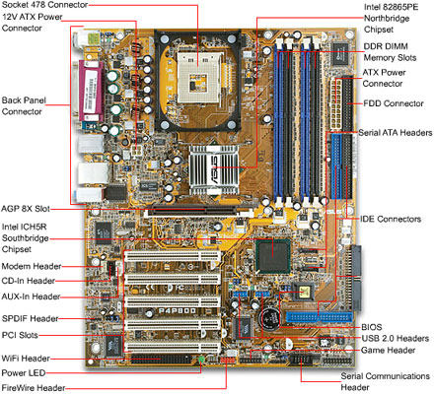

Typical Desktop Motherboard (above) iPhone 3 motherboard (below)
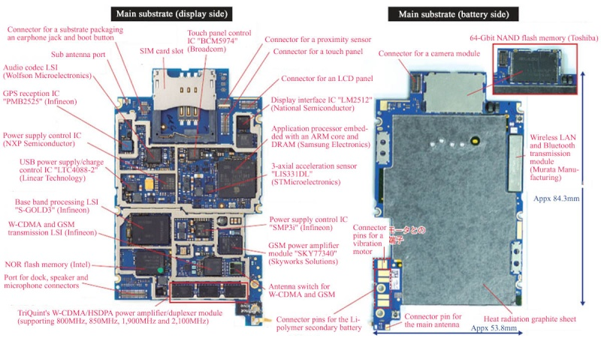
5. Input-Output Devices & Sensor Technology

Before a computer/robot/mobile device can process your data, you need some method to input the data into the machine. The device you use will depend on what form this data takes (be it text, sound, artwork, etc.). Similarly, after the computer has processed your data, you often need to produce output of the results. This output could be a display on the computer screen, hardcopy on printed pages, or even the audio playback of music you composed on the computer.

The terms “input” and “output” are used both as verbs to describe the process of entering or displaying the data, and as nouns referring to the data itself entered into or displayed by the computer.

Robots are designed to interface with some aspect of the physical world and this is done through the use of sensors. Sensors allow the computer/robot to monitor some detectable phenomenon. There are a plethora of sensors available to use and many mobile devices today have built-in sensors and that even web pages make use of sensors technology. The diagram below shows some of the sensors found in various computing devices today.

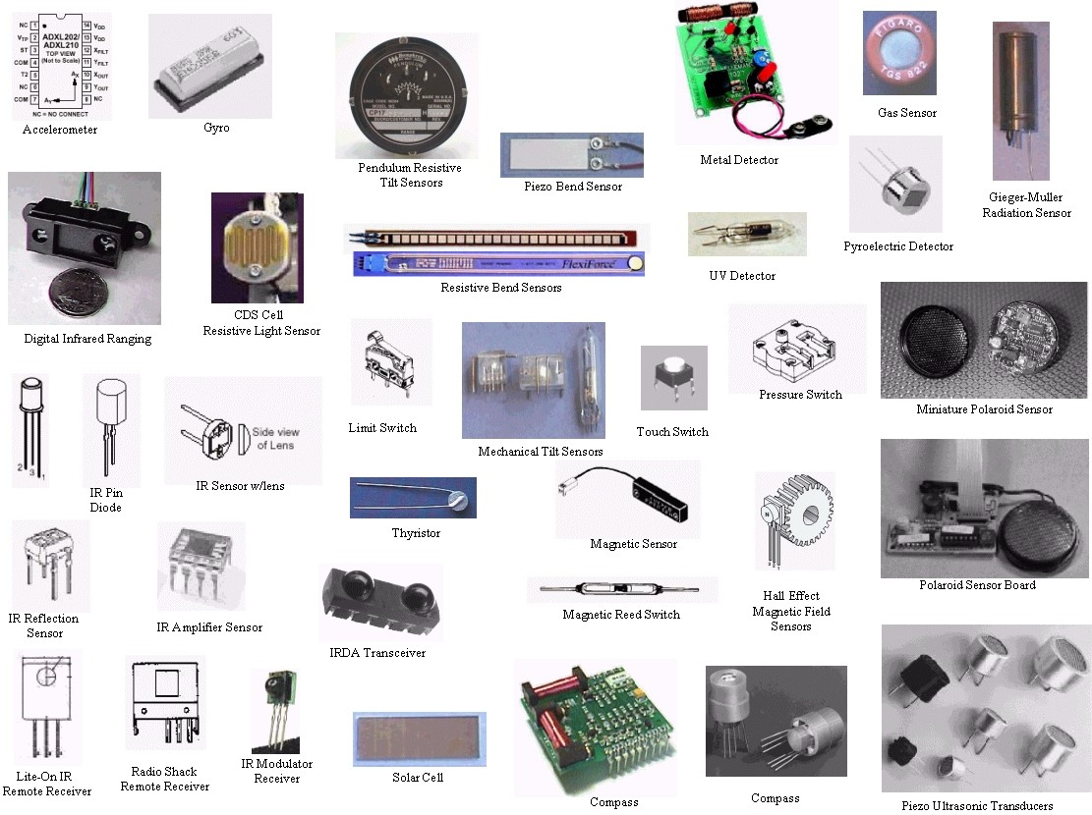
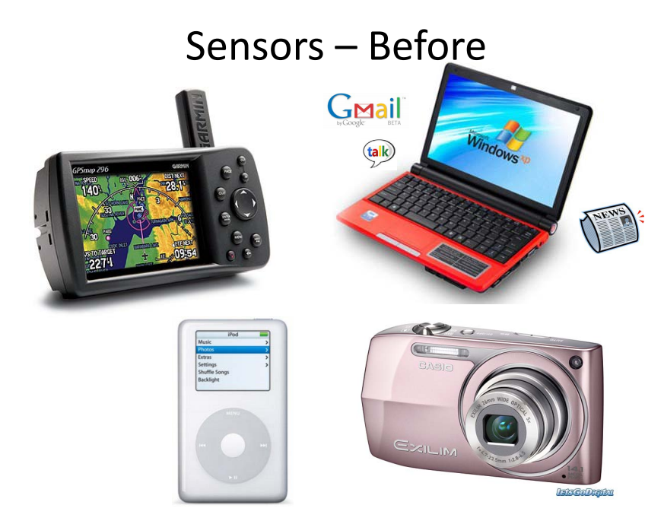
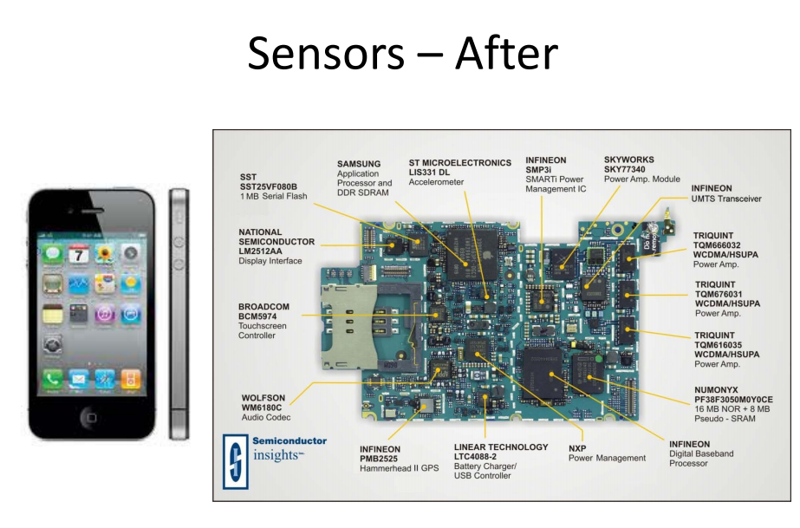

Part 3: Types of Software

Software is often divided into two categories—systems software and application software. Systems Software includes programs that interface with the hardware and manage computer resources at a low level. System software allows the computer to function and supports application software.

The operating system (OS) handles the routine operations of a computer system such as file management, printing, input, and storage. Examples include: Windows (PCs), MacOS (Apple), Unix, Linux, Android.

Utility software helps to maintain the "health" of your computer system and/or diagnose any problems. Examples include file scan, disk defragger, virus protection, malware protection, and file compression (zip files).

Another type of software is the compiler which is a computer program that transforms source code written in a programming language (the source language) into binary form, which is known as object code. The most common reason for wanting to transform source code is to create an executable program on some device.

In every browser is yet another program called an interpreter. It executes (performs) instructions written in a certain programming language for use on the internet. These languages include HTML5, Javascript, python and more.

Application Software includes programs that are designed to do work for the end users. There are many examples of applications today including MS-Office, Corel Draw, and more.

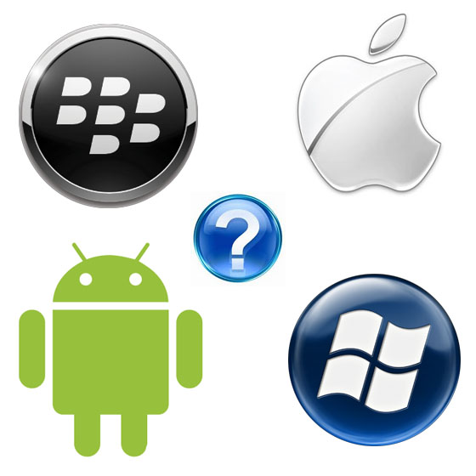
The changing look of computers:

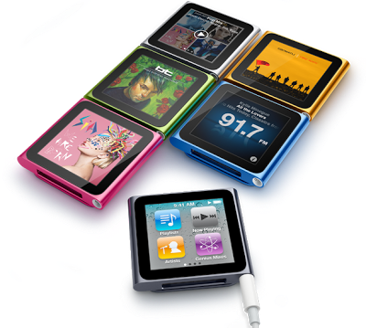
When most people hear the word "computer" they think of a personal computer such as a desktop or laptop computer. However, computers come in many shapes and sizes, and they perform many different functions in our daily lives. When you withdraw cash from an ATM, scan groceries at the store, or use a calculator, you're using a type of computer. TEJ4M students built the game ‘pong’ using a PIC16F84 microcontroller from MicroChip. They ‘burned’ instructions into the chip, wired the various components including joystick ports, and hooked it up to a TV. In essence, they built a computer. Microcontrollers are everywhere today and thus computers have taken on a whole new look. Take for example, the Apple iPod Nano. Is a computer? …YES … does it do word processing … No , however it does have the key features of a computer: CPU, working memory, input, output and storage.

Desktops, Laptops, and Server Computers

Most BR students have used a desktop computer either at home, at school, or in the library. There are plenty of desktops at BR for students to use. They can be small, medium, or large in style, and usually sit on a desk. Once you add a monitor, mouse, and a keyboard, you have what is typically known as a desktop computer. Most desktop computers are easy to upgrade and expand, or add new parts. Another benefit of desktop computers is the cost. If you compare a desktop and a laptop with the same features, you will most likely find that the desktop computer is priced lower. Many smaller computer stores in Milton sell ‘custom built’ desktop computers. Many SHSM students have done coop placements at these stores and learned how to assemble these computers.

Over the past five years at BR, there has been a big swing away from desktops and into laptops. Laptops are battery or AC-powered personal computers that are more portable than desktop computers, allowing you to use them almost anywhere. Since a laptop is smaller than a desktop, it's more difficult to access the internal components. That means you may not be able to upgrade them as much as a desktop. However, it's usually possible to add more RAM or a bigger hard drive.

You have all used a server to store your files. Your ‘H’ drive is a server located somewhere that stores all student files. A server is a computer that "serves up" information to other computers on a network. Many businesses have file servers that employees can use to store and share files. A server can look like a regular desktop computer, or it can be much larger. Servers also play an important role in making the internet work: they are where web pages are stored. When you use your browser to click a link, a web server delivers the page you requested. Our engineering server has the address: brweb.hcdsb.org\bizeng.asp .

And still ….other types of computers

Today, there lots of everyday devices which are specialized computers, even though we don't always think of them as computers. Here are a few common examples:
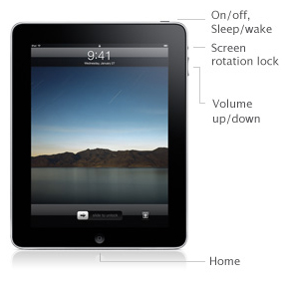
Tablet Computers:

These use a touch-sensitive screen for typing and navigation. Since they don't require a keyboard or mouse, tablet computers are even more portable than laptops. The iPad is an example of a tablet computer. Different types of tablets use different operating systems. Examples include Android and iOS. Tablets use solid-state drives, which allow the computer to boot up and open programs more quickly. They are also more durable than hard disk drives. Since they are optimized for internet use, tablet computers have built-in Wi-Fi. (For a monthly fee, you can also purchase a 3G or 4G data plan, allowing you to access the internet from almost anywhere.) In order to save space, tablet computers have very few ports. If you want to use an external keyboard or other peripherals, they will often use a wireless Bluetooth connection.

Mobile Phones:

Many mobile phones can do a lot of things a computer can do, such as browsing the internet or playing games. These phones are often called smartphones.

Game Consoles:

A game console is a specialized kind of computer that is used for playing video games. Although they are not as fully-featured as a desktop computer, many newer consoles, such as the Nintendo Wii, allow you to do non-gaming tasks like browsing the internet.

TVs:

Many TVs now include applications (or apps) that let you access various types of online content. For example, you can view your Facebook news feed or watch streaming movies on Netflix.
How Computer Memory Is Measured

Bit: All computers work on a binary numbering system, i.e. they process data in one's or zero's. This
1 or 0 level of storage is called a bit.

Byte: A byte consists of eight bits.
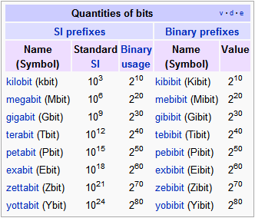

What Operating System do mobile devices use?
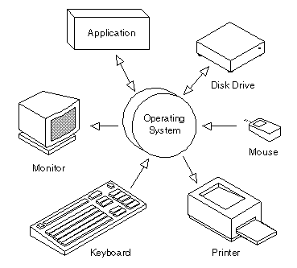
As mentioned previously, an operating system is the most important software that runs on a computer. It manages the computer's memory, processes, and all of its software and hardware. It also allows you to communicate with the computer without knowing how to speak the computer's "language." Without an operating system, a computer is useless. Popular mobile operating systems for mobile devices include:

- Java ME Platform
- Windows Mobile OS
- BlackBerry OS
- iPhone OS
- Google Android Platform

Desktop vs Mobile Device Operating systems

The design and capabilities of a mobile OS (Operating System) is very different than that of a general purpose OS running on desktop machines. Mobile devices have constraints and restrictions on their physical characteristic such as screen size, memory, processing power and etc. due to their footprint. They have scarce availability of battery power and limited amount of computing and communication capabilities. Thus, they need different types of operating systems depending on the capabilities they support. e.g. an iPAd’s OS is different from a Smartphone OS.
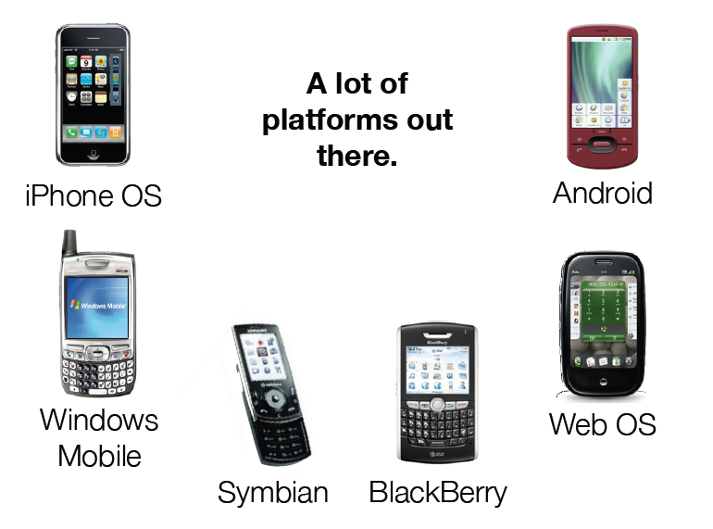
There are a lot of different mobile operating systems out there…when writing apps, one needs to know the type of device operating system before coding in order to take advantage of the type of hardware in the device.

