TEJ101 Engineering
Activity 12:  Binary & Hexadecimal Numbers | No. of Classes: 2 | Students Name:

Background: Data in robots and computers is stored and transmitted as a series of zeros and ones. This activity will demonstrate how you can represent words and numbers using just these two symbols – ZERO & ONE

Objectives: In this activity, students will:

- investigate the use of binary numbers ;
- convert decimal numbers to binary numbers;
- convert binary numbers to decimal numbers; and
- convert binary numbers to hexadecimal numbers

References:

1. Khan Academy Binary Number video tutorial
https://www.khanacademy.org/science/computer-science/v/binary-numbers
2. Binary and hexadecimal number tutorials
http://brweb.hcdsb.org/202204/ICS3UPU03A01/content.html

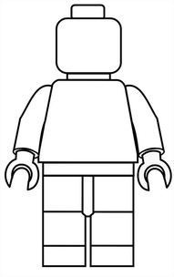
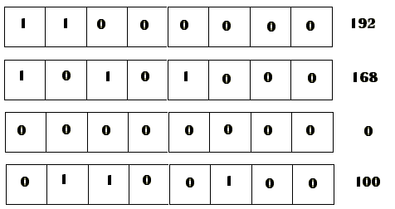
0
1
Part 1: The Binary and Hexadecimal Number Systems

Instructions:
1. Watch the first video in the references. It is just over 10 minutes long

2. Goto the second reference website and take the on-line tutorial that explains computer number systems.
3. After steps 1 & 2, read the activity notes below and complete all exercises and questions.
Did you know ….Robots Use Binary Numbers!

Robots, which are computers with sensors, use the binary number system to represent information. It is called binary because only two different digits are used and is sometimes referred to as base two. Normally humans use the base 10 number system, which is referred to as decimal, for everyday use There are many different number systems to use but decimal is convenient for humans … however for computers and robots which are made up of millions of tiny electronic switches, base 2 or the binary number system is most appropriate.

Binary means "two states." The two states are sometimes called "1" and "0", or called "true" and "false", or called "on" and "off", (or other names.) The essential characteristic is that a single binary device can be in just one of two possible states. For example, storage devices such as flash sticks and hard drives, store information magnetically, that is the bits of information are represented by the direction of a magnetic field on a coated surface. (either North-South or South-North). On DVDs, bits are represented optically—the part of the surface corresponding to a bit either does or does not reflect light. Another good example of a binary device is a toggle switch, such as a light switch. You can turn it "on" or "off" but not (in normal operation) anything else. A light switch holds one bit of information. (A light dimmer, however, is not a binary device: it has many positions between "off" and "fully on". If you want a light dimmer to be set to 25%, you must carefully adjust it.)

Each zero or one is called a bit (binary digit). A bit is usually represented in a computer’s main memory by a tiny electronic switch (transistor) that is either on or off. One bit on its own can’t represent much, so they are usually grouped together in groups of eight, which can represent numbers from 0 to 255. A group of eight bits is called a byte.

Ultimately bits and bytes are all that a robot/computers/smartPhones uses to store, process and transmit numbers, text, and all other information. The more digital electronics our society uses, the more there will be binary numbers all around us! In the figure below, you can represent the binary number by whether a card is face up or not. A ‘0’ shows that a card is hidden, and 1 means that you can see the dots. The pattern below therefore, shows 9 dots or 01001 in binary!

Part 2: Working with the Binary Number System

Instructions
- Below is your set of “binary cards” to use in answering the questions below. Notice that each card has a place value related to the binary number system. Begin by imagining all your cards are ‘FACE UP’.

Column
Place
value

Card 5  16s | Card 4  8s | Card 3  4s | Card 2  2s | Card 1  1s

2. Begin by turning face down, the fifth, fourth and second cards so you cannot see the dots on them. Next record the pattern of the cards by placing a ‘1’ where the card is face up, in the corresponding box below, and a ‘0’ where the card is face down.

[Your pattern should be ‘00101’. This is the binary representation for the decimal number ‘5’!]

3. Next imagine all of your cards are face up. Create a pattern that shows only three dots. Again, if the card is showing dots, place a ‘1’ in the box, otherwise place a ‘0’.

4. Congratulations! Your next step is to create a pattern that shows 10 dots. Remember; do not change the order of your cards.

5. Wow..Your doing Great! Your next step is to create a pattern that shows 31 dots. Remember; do not change the order of your cards.

6. This time we are going to change it up a ‘bit’ ☺ Turn all of your cards over (face down) and create the following pattern.
1 | 1 | 0 | 0 | 1
How many dots are showing? _________
7. Ready for more … Turn all of your cards over (face down) and create the following pattern.
0 | 0 | 1 | 1 | 1
How many dots are showing? _________

8. If you were to add one more card to the left side of your cards, how many dots would be on it? ____

Part 3: Counting ‘binary’ numbers on your hand!

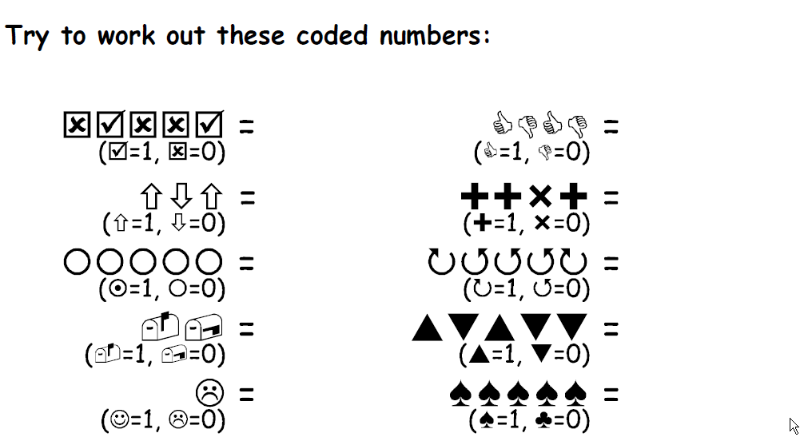
01001
A
B
C
D
E

...which equals 9 in decimal
...which equals ___in decimal
...which equals ___in decimal
...which equals ___in decimal
...which equals ___in decimal

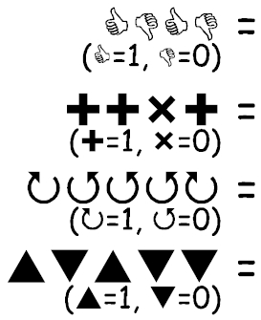
F
...which equals ___in decimal

G
...which equals ___in decimal

H
...which equals ___in decimal

I
...which equals ___in decimal

What is your age in binary? _________________
What is your grade in binary? _________________

Binary – Hexadecimal – Decimal Conversions

1. The decimal number 254 in binary is

A. 11111110 B. 1110001 C. 1011100 D. 1110111

2. The decimal number 127 in binary is ...

A. 1001111 B. 1011110 C. 1111111 D. 1010101

3. The decimal number 8 in binary is

A. 1011 B. 1100 C. 1000 D. 1110

4. The decimal number 10 in binary is

A. 1111 B. 1110 C. 1010 D. 1100

5. The decimal number 13 in binary is

A. 1001 B. 1101 C. 1010 D. 1100

6. The decimal number 20 in binary is

A. 10100 B. 11100 C. 10010 D. 10101

7. The decimal number 1 in binary is

A. 1101 B. 1100 C. 1010 D. 0001

8. The decimal number 64 in binary is

A. 1110100 B. 1100000 C. 1010001 D. 1000000

9. 010101012 in hexadecimal (h) is

A. 66h B. 55h C. 44h D. 645h

10. 010001002 in hexadecimal is

A. 44h B. 33h C. 43h D. 34h

11. 000100102 in hexadecimal is

A. 11h B. 22h C. 21h D. 12h

12. Which number is largest??

A. 2510 B. 1916 C. 318 E. 110102

13. Which number is largest??

A. 2010 B. 1916 C. 248 E. 010102

14. True or False? The binary number 1101 is equal to 13 decimal.

A. True B. False

15. The decimal number 15 is equal to the hexadecimal number F16. What is the hexadecimal equivalent of decimal 16?

A. G16 B. 116 C. 1F16 E. 1016

16. True or False? Binary numbers are always used for indicating colours on web pages.

A. True B. False

17. Which colour below is red?

A. #000000 B. #FF00FF C. #FF0000 D. #00FF00
E. None of the above

18. Which colour below is black?

A. #000000 B #FF00FF C. #FF0000 D. #00FF00
E. None of the above

19. Which colour below is green?

A. #000000 B. #FF00FF C. #FF0000 D. #00FF00
E. None of the above

20. Which colour below is white?

A. #000000 B. #FFFFFF C. #FF0000 D. #00FF00
E. None of the above

21. What is the binary value for the YELLOW colour shown below in the dialog box?

______________________ |_____________________ | ________________________
Red green blue

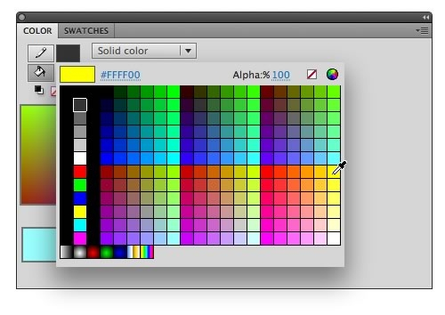

22 . What does the word binary mean?

A. Binary means "containing a computer."
B. Binary means "having only two states."
C. Binary means "having a discrete number of values."
D. Binary means "using electronics to do arithmetic."

23. What is a bit?

A. A bit is a single binary value.
B. A bit is a single character stored in main memory.
C. A bit is a collection of several bytes.
D. A bit is a small unit of computer time.

24. Which of the following is NOT an advantage of building computers out of binary devices?

A. Binary devices are simple and easy to build.
B. Binary signals are unambiguous.
C. Binary devices are much faster than decimal devices.
D. Patterns of bits can be used to represent anything symbolic.

25. From the choice below, circle those that are binary devices.

A. The ignition switch of an automobile.
B. The hour hand of a clock.
C. A button on a hand calculator.
D. The volume control on a stereo.

