TEJ Activity 11 | Engineering @ BR  All about Wire | Wednesday, July 29, 2026
Name: | Engineering @ BR  All about Wire | Wednesday, July 29, 2026

Background:
When someone mentions the word wire, they are more than likely referring to a flexible, cylindrical piece of metal that can vary in size from just a few millimeters in diameter to several centimeters. Wire can refer to either a mechanical or electrical application. An example of a mechanical wire could be a Guy-wire, but this this guide will focus on electrical wiring.
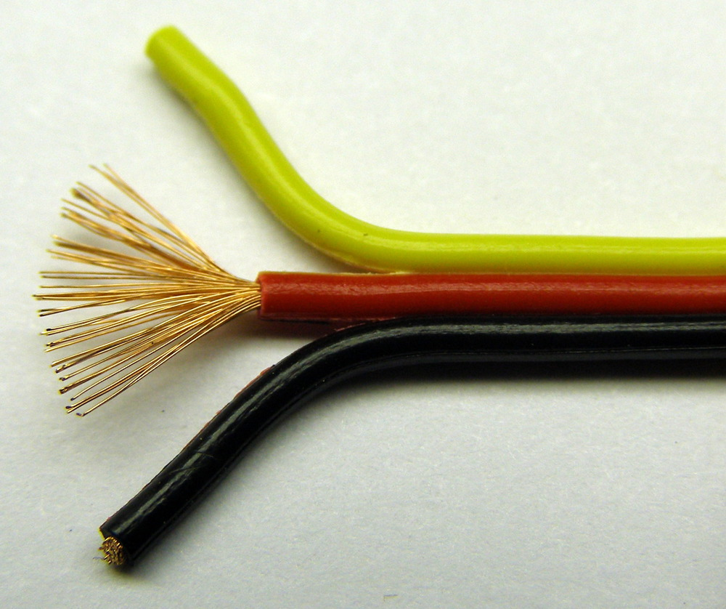

Inside a stranded wire

Electrical wire is a backbone of our society. There is wire in houses to turn on lights, heat the stove, and even talk on the phone. Wire is used to allow current to flow from one place to another. Most wires have insulation surrounding the metallic core. An electrical insulator is a material whose internal electric charges do not flow freely and, therefore, does not conduct an electric current. A perfect insulator does not exist, but some materials such as glass, paper and Teflon, which have high resistivity, are very good electrical insulators. Insulation exists because touching a bare wire could allow current to flow through a persons body (bad) or into another wire unintentionally.

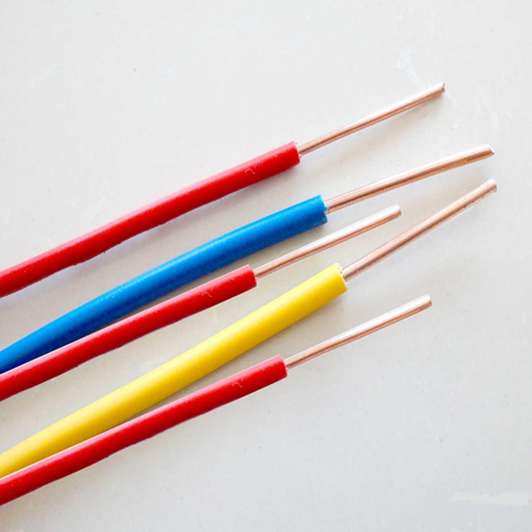
Solid Wire
Solid Wire

Solid wire is composed of a single piece of metal wire, also known as a strand. One very common type of solid wire is known as wire wrap. Stranded wire is composed of many pieces of solid wire all bundled into one group.

Stranded Wire
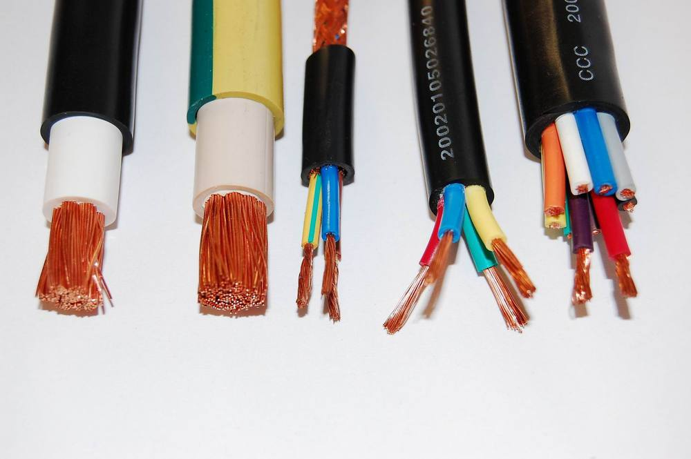
Stranded wire is much more flexible than solid wire of equal size. For this reason, stranded wire is used when the wire needs to move around frequently, in a robot arm for example. Conversely, solid wire is used when little or no movement is needed, such as prototyping circuits on a breadboard. Using solid core wire makes it easy to push the wire into a breadboard. Trying to use stranded wire on a breadboard can be very difficult, as the strands want to separate as they are pressed in.

Wire Thickness

The term ‘gauge’ is used to define the diameter of the wire. The gauge of a wire is used to determine the amount of current a wire can safely handle. Wire gauge can refer to both electrical and mechanical. This tutorial will only cover electrical. There are two main systems for measuring gauge, American Wire Gauge (AWG) and Standard Wire Gauge (SWG). The differences between the two are not critical to this guide.

Wire Gauges
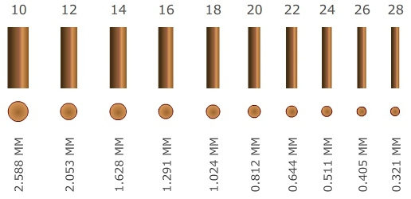
An approximate scale of several different gauges of wire

The amount of current that a wire can carry depends on a few different factors, for example the composition of the wire, wire length, and condition of the wire. In general, thicker wire can carry more current.

Amps to Gauge
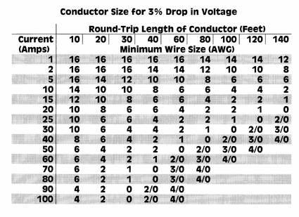
An approximate wire thickness to current capability chart

Typically in our course we use 22 AWG wire for prototyping and breadboarding. When using a breadboard, the solid core is perfect because it fits nicely into the breadboard holes. For other prototyping/building involving soldering, the stranded core is better , just be sure not to let too much current run through a single wire, it will get hot and could melt!

How to Strip a Wire
Safe, durable electrical connections begin with clean, accurate wire stripping. Removing the outer layer of plastic without nicking the wires underneath is critical. If a wire does get nicked, the connection may break or an electrical short may occur.

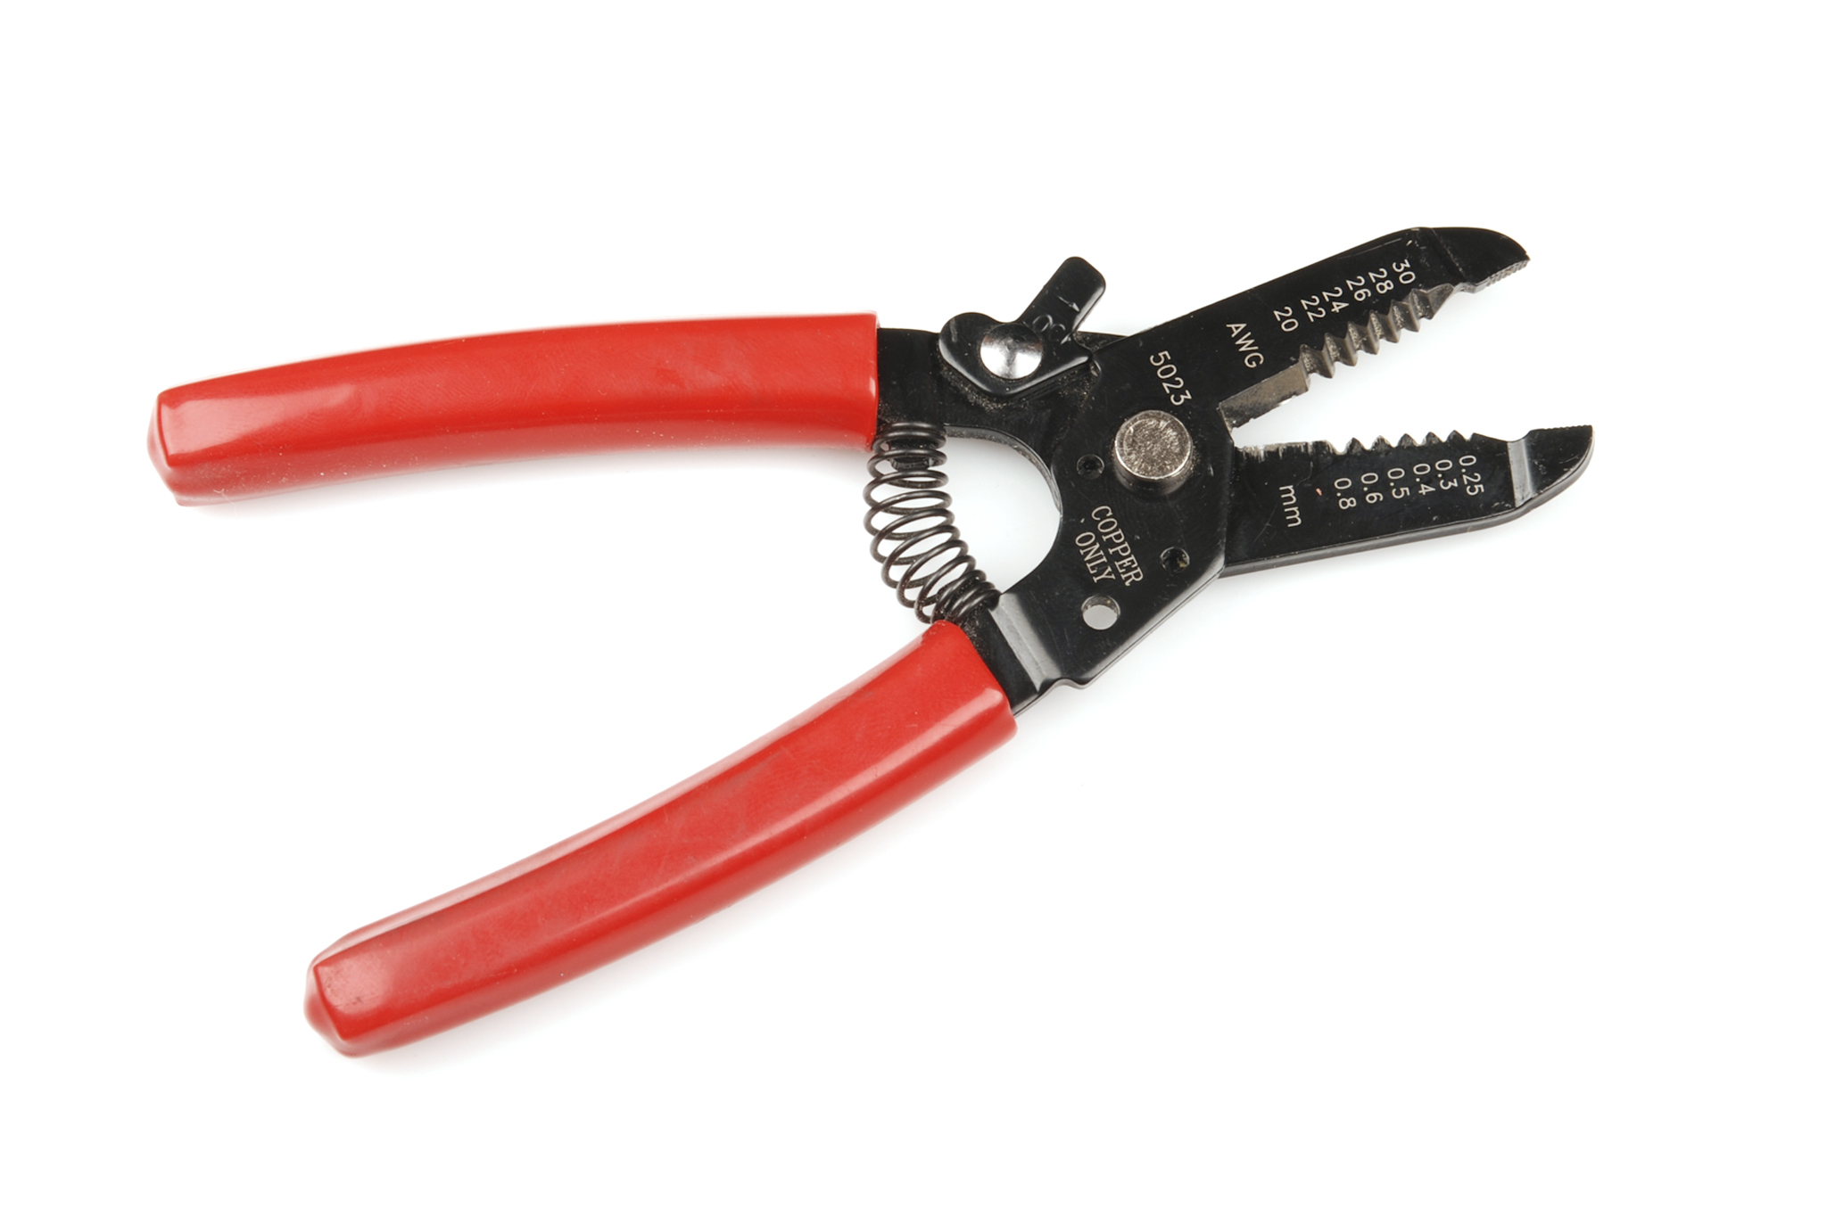
Wire Stripper

A simple manual wire stripper is a pair of opposing blades much like scissors. There are several notches of varying size. This allows the user to match the notch size to the wire size, which is very important for not damaging the wires.

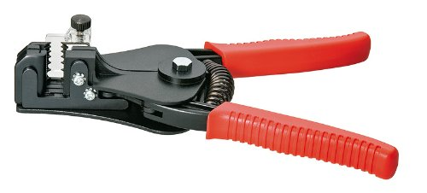
Warning: Many wire strippers found at the hardware store do not strip small gauge wire (22 to 30). When getting into prototyping, be sure to get a tool that is capable of stripping 22 AWG and smaller. Being able to strip very small 30 AWG wire (also known as wire wrap wire) is advantageous.

Although a knife would also strip the wires, it may also damage the wire by nicking the metal or cutting into it. Using a knife to strip wire is also really dangerous! The knife can easily slip and cause wicked injuries.

Stripping the Wire

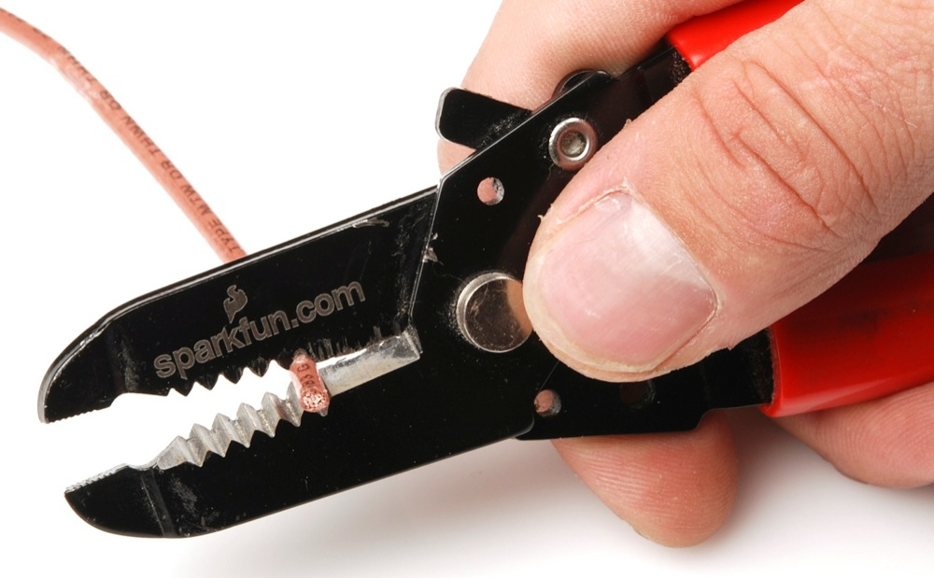
By simply squeezing the handles about ¼" from the end of the wire or the desired length, using the correct notch on the tool, and then twisting it slightly, the insulation will be cut free.

Wire After Strip- Then by pulling the wire strippers towards the end of the wire, the insulation should slide right off of the wire.

Tips, Tricks, and Hints-

It is important to match the size of wire to the correct notch in the stripper. If the notch is too large, the wire will not get stripped. If the notch is too small, there is a risk of damaging the wire. Using an undersized notch means the strippers will close too far, digging into the wire underneath. With stranded wire, the tool will cut off the outer ring of wires, decreasing the total diameter of wire and reduce the strength of the wire. A nick in solid core wire will severely reduce the strength and flexibility of the wire. The likelihood of the wire breaking upon being bent increases significantly.

Damaged Wire - This wire was not stripped properly, there are gouges and missing strands. If a wire does accidentally get a nick in it, the best plan of action is to cut the damaged part of the wire off and try again.

