TEJ Activity 10 | Engineering @ BR  Common Circuit Components |   Friday, July 31, 2026
Name: | Engineering @ BR  Common Circuit Components
-
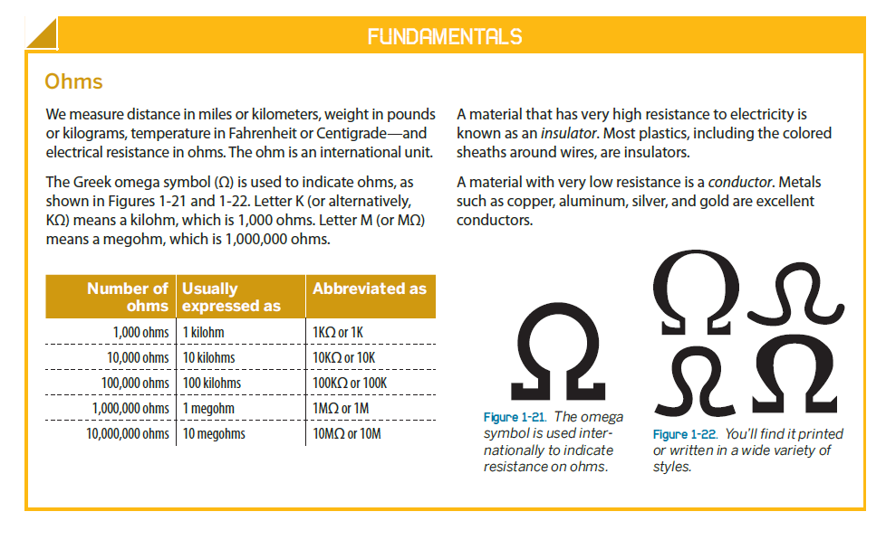
All circuits have …..Resistance …resistors

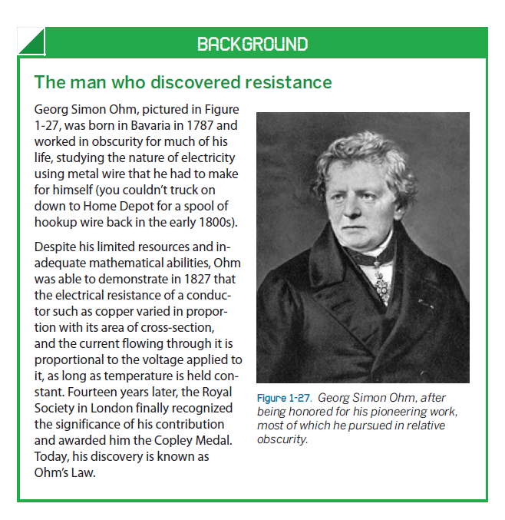
How to read colour bands on Resistors

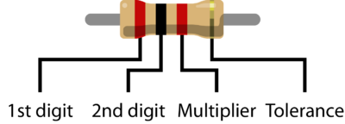

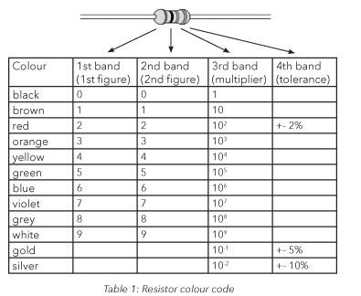

Resistors
The most fundamental of circuit components and symbols! Resistors on a schematic are usually represented by a few zig-zag lines, with two terminals extending outward. Schematics using international symbols may instead use a featureless rectangle, instead of the squiggles.
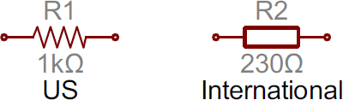

Potentiometers and Variable Resistors
Variable resistors and potentiometers each augment the standard resistor symbol with an arrow. The variable resistor remains a two-terminal device, so the arrow is just laid diagonally across the middle. A potentiometer is a three-terminal device, so the arrow becomes the third terminal (the wiper).
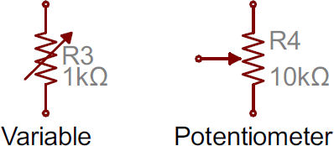

Capacitors
There are two commonly used capacitor symbols. One symbol represents a polarized (usually electrolytic or tantalum) capacitor, and the other is for non-polarized caps. In each case there are two terminals, running perpendicularly into plates.
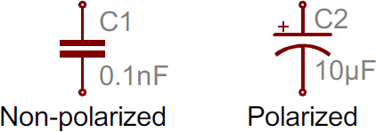
The symbol with one curved plate indicates that the capacitor is polarized. The curved plate represents the cathode of the capacitor, which should be at a lower voltage than the positive, anode pin. A plus sign might also be added to the positive pin of the polarized capacitor symbol.

Batteries
Batteries, whether they’re those cylindrical, alkaline AA’s or rechargeable lithium-polymers, usually look like a pair of disproportionate, parallel lines:
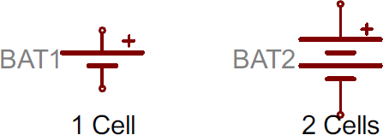
More pairs of lines usually indicate more series cells in the battery. Also, the longer line is usually used to represent the positive terminal, while the shorter line connects to the negative terminal.

Power Sources
Just as there are many options out there for powering your project, there are a wide variety of power source circuit symbols to help specify the power source.

DC or AC Voltage Sources
Most of the time when working with electronics, you’ll be using constant voltage sources. We can use either of these two symbols to define whether the source is supplying direct current (DC) or alternating current (AC):
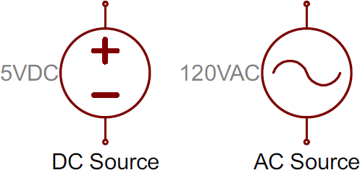

Diodes
Basic diodes are usually represented with a triangle pressed up against a line. Diodes are also polarized, so each of the two terminals require distinguishing identifiers. The positive, anode is the terminal running into the flat edge of the triangle. The negative, cathode extends out of the line in the symbol (think of it as a - sign).
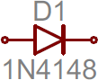
There are a all sorts of different types of diodes, each of which has a special riff on the standard diode symbol. Light-emitting diodes (LEDs) augment the diode symbol with a couple lines pointing away. Photodiodes, which generate energy from light (basically, tiny solar cells), flip the arrows around and point them toward the diode.
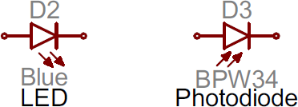

Transistors
Transistors, whether they’re BJTs or MOSFETs, can exist in two configurations: positively doped, or negatively doped. So for each of these types of transistor, there are at least two ways to draw it.

Bipolar Junction Transistors (BJTs)
BJTs are three-terminal devices; they have a collector (C), emitter (E), and a base (B). There are two types of BJTs – NPNs and PNPs – and each has its own unique symbol.
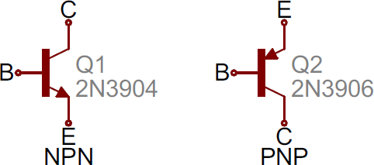
The collector (C) and emitter (E) pins are both in-line with each other, but the emitter should always have an arrow on it. If the arrow is pointing inward, it’s a PNP, and, if the arrow is pointing outward, it’s an NPN. A mnemonic for remembering which is which is “NPN: not pointing in.”
Assignment:

Calculate the resistance of the following codes.

Band 1 | Band 2 | Band 3 |  | Value
Black | Brown | Brown | Silver
Red | Red | Red | Gold
Brown | Red | Black | Silver
Yellow | Red | Yellow | Silver
Blue | Green | Red | no band
Black | Gray | Green | Gold
Gray | Blue | Orange | Silver
Violet | Violet | Brown | no band
Yellow | Brown | Red | Silver
Black | Brown | Black | Silver

Internet of Things
Another high-concept, revolution-in-the-making will finally start to hit home for Canadian consumers and businesses alike in 2018. IDC, in its first-ever Canadian Internet of Things (IoT) report, said the current $5.6 billion market for products and services will grow 30 per cent annually and hit $21 billion by 2018.
Cisco in March chose Toronto as the site of one of its four global Internet of Everything Innovation Centres, and is expected in 2017 to move forward on its 10-year, $4 billion commitment to bring 1,700 research-and-development-related jobs to the Canadian market. As global players like Cisco set their sights on developing a Canadian IoT ecosystem and as businesses here gradually warm to the competitive potential of connecting virtually everything in their midst, expect a growing wave of startups fo dive in full-force and bring solutions to market. With traditional tech platforms like PCs moving into their post-geriatric phase and mobile platforms approaching saturation, IoT is emerging as the next significant growth market not only for tech players, but for the broader economy, as well.
Goto http://www.physics.uoguelph.ca/~phyjlh/Prob/Soweto/ElectricityII%20(multiple%20choice%20questions).mht and take the online test.

Reference:

http://labs.stijncoppens.com/thesis/technical/controlling-leds/

