2016 2017 ICS3U Computer Science @ BR
Activity 01  Pixels & Processing |  | Students Name:

Background:

This Activity will introduce the concept of Computer Science and explain what a Computer Scientist does. It will also give students an opportunity to assume the role of a computer scientist.

Vocabulary:

Automate To make something happen without assistance from people.
Computer Science The art of blending human ideas and digital tools to increase problem solving power.
Computer Scientist A person who is skilled at modifying problems for digital solutions.
Data Information, including: facts, samples, names and numbers.
Open Source Software that is created for free use by everyone.
Programming Writing instructions for a digital tool.
Algorithm Computer programming is writing algorithms. An algorithm is a sequential list of instructions that solves a particular problem. The philosophy of incremental development (which is essentially an algorithm for you, the human being, to follow) is designed to make it easier for you to write an algorithm that implements your idea.

Activity Objectives:
In this activity students will learn to:
- specify pixel coordinates;
- draw basic shapes: point, line, rectangle, ellipse;
- colour: greyscale, "RGB"
- colour transparency

Reference Videos:

1. What is Programming?
https://www.khanacademy.org/computing/computer-programming/programming/intro-to-programming/v/programming-intro

2. What is Processing?
http://funprogramming.org/1-Introduction.html

3. What are radians?
https://upload.wikimedia.org/wikipedia/commons/4/4e/Circle_radians.gif

4. Drawing a face with code:
https://www.khanacademy.org/computing/computer-programming/programming/drawing-basics/p/making-drawings-with-code

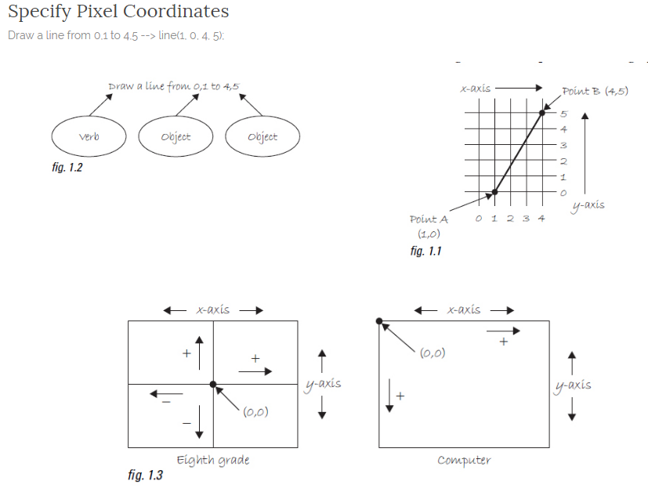

Figure 1.1 above shows a line between point A (1,0) and point B (4,5). If you wanted to direct a friend of yours to draw that same line, you would give them a shout and say “ draw a line from the point one-zero to the point four-five, please. ”Well, for the moment, imagine your friend was a computer and you wanted to instruct this digital pal to display that same line on its screen. The same command applies. Here, the instruction will look like this:
line(1,0,4,5);

Congratulations ICS3U students, you have written your first line of computer code! We will get to the precise formatting of the above later, but for now, even without knowing too much, it should make a fair amount of sense. We are providing a command (which we will refer to as a “ function ” ) for the machine to follow entitled “ line. ”In addition, we are specifying some arguments for how that line should be drawn, from point A (0,1) to point B (4,5). If you think of that line of code as a sentence, the function is a verb and the arguments are the objects of the sentence. The code sentence also ends with a semicolon instead of a period.

The key here is to realize that the computer screen is nothing more than a fancier piece of graph paper. Each pixel of the screen is a coordinate—two numbers, an “ x”(horizontal) and a “ y”(vertical)—that determine the location of a point in space. It is your job to specify what shapes and colors should appear at these pixel coordinates.

Nevertheless, there is a catch here. The graph paper from eighth grade ( “ Cartesian coordinate system ” )
placed (0,0) in the center with the y-axis pointing up and the x-axis pointing to the right (in the positive
direction, negative down and to the left). The coordinate system for pixels in a computer window,
however, is reversed along the y -axis. (0,0) can be found at the top left with the positive direction to the
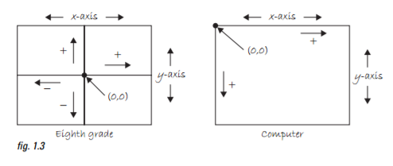
right horizontally and down vertically. See Figure 1.3 .

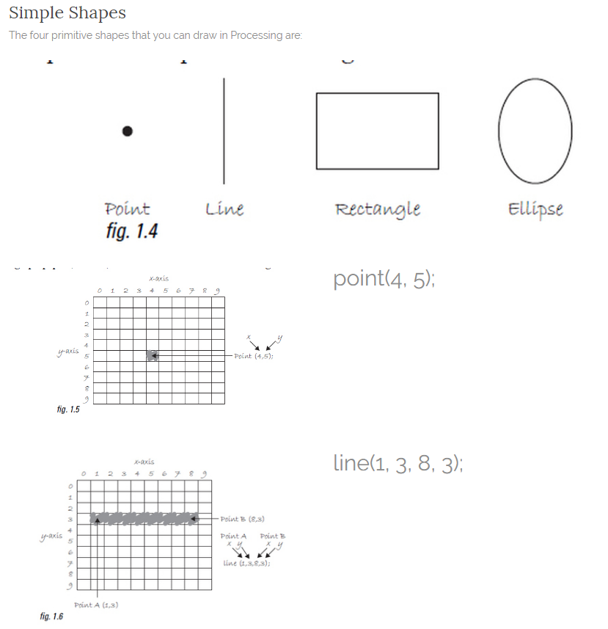

Exercise 1:
Using the graph paper, draw the primitive shapes defined by the code.
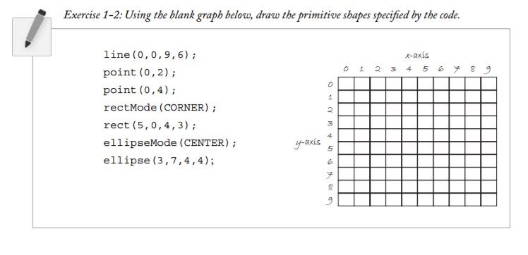

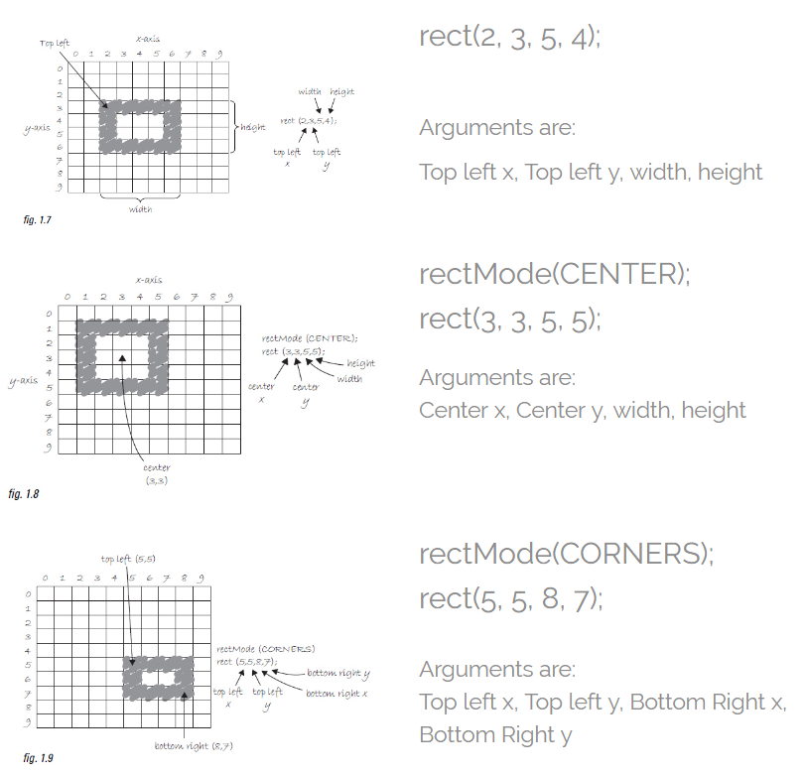

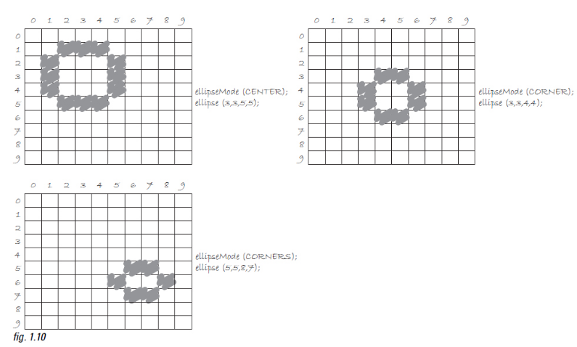

It is important to acknowledge that in Figure 1.10 , the ellipses do not look particularly circular. Processing has a built-in methodology for selecting which pixels should be used to create a circular shape. Zoomed in like this, we get a bunch of squares in a circle-like pattern, but zoomed out on a computer screen, we get a nice round ellipse. Later, we will see that Processing gives us the power to develop our own algorithms for coloring in individual pixels (in fact, we can already imagine how we might do this using “ point ”over and over again), but for now, we are content with allowing the “ ellipse ”statement to do the hard work.
Exercise 2:
Reverse engineer a list of primitive shape drawing instructions for the diagram below.
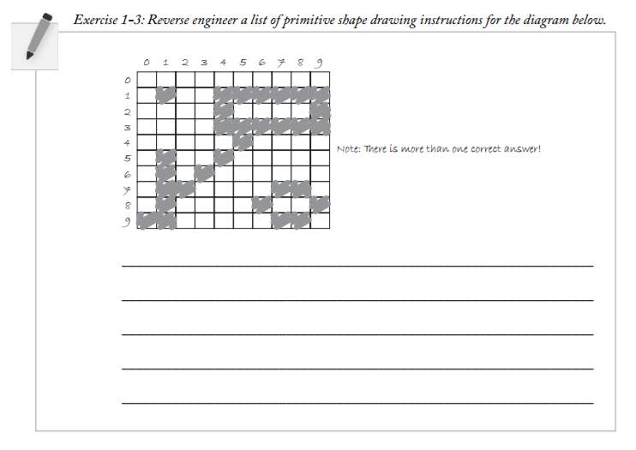

Key Points from Activity:

- The default mode for ellipse( ) is “CENTER”.
- The default mode for rect( ) is "CORNER".
- In total, there are three modes to utilize to position your shapes.

Assignment:

Using Processing, create your own Emoji. Use a 500x500 pixel output window. See some examples below or research your own. Try to use all of the commands you have learned so far. Create at least three Emoji's and write the code for each in separate files. Save your programs in a Unit 1 folder, in your H drive as MyEmoji1, MyEmoji2, etc. or give them unique names such as Smiley, Sleepy, etc


