TEJ ICT SHSM Engineering
Activity 1:  Trends in digital technology | No. of Classes: 2 | Students Name:

Objectives: In this activity, students will:

- Explore the concept of transistors and their use in computer hardware;
- Investigate Moore’s Law
- Research post-secondary programs in engineering

Part 1: Moore's Law
Moore's law (Gordon Moore, Intel co-founder) states that the density of transistors on a chip doubles about every 2 years or so (sometimes listed as every 18 months). It is not a scientific law, just a broad prediction that seems to keep working. This ‘law’ captures the idea that per dollar, computer technology (not just transistors) gets exponentially better as time goes along. This is quite clear if you look at the cost or capability of computers/cameras etc. you have owned. In general, it means each new generation of computers is more powerful and capable than the previous generation. For example, many smartphones today have more computing power than the Apollo spaceship that landed on the moon! Clearly, computing power continues to get cheaper and thus computer are now finding their way into more in more places in our everyday lives. The mathematical representation of Moore’s Law can be represented by the following formula:

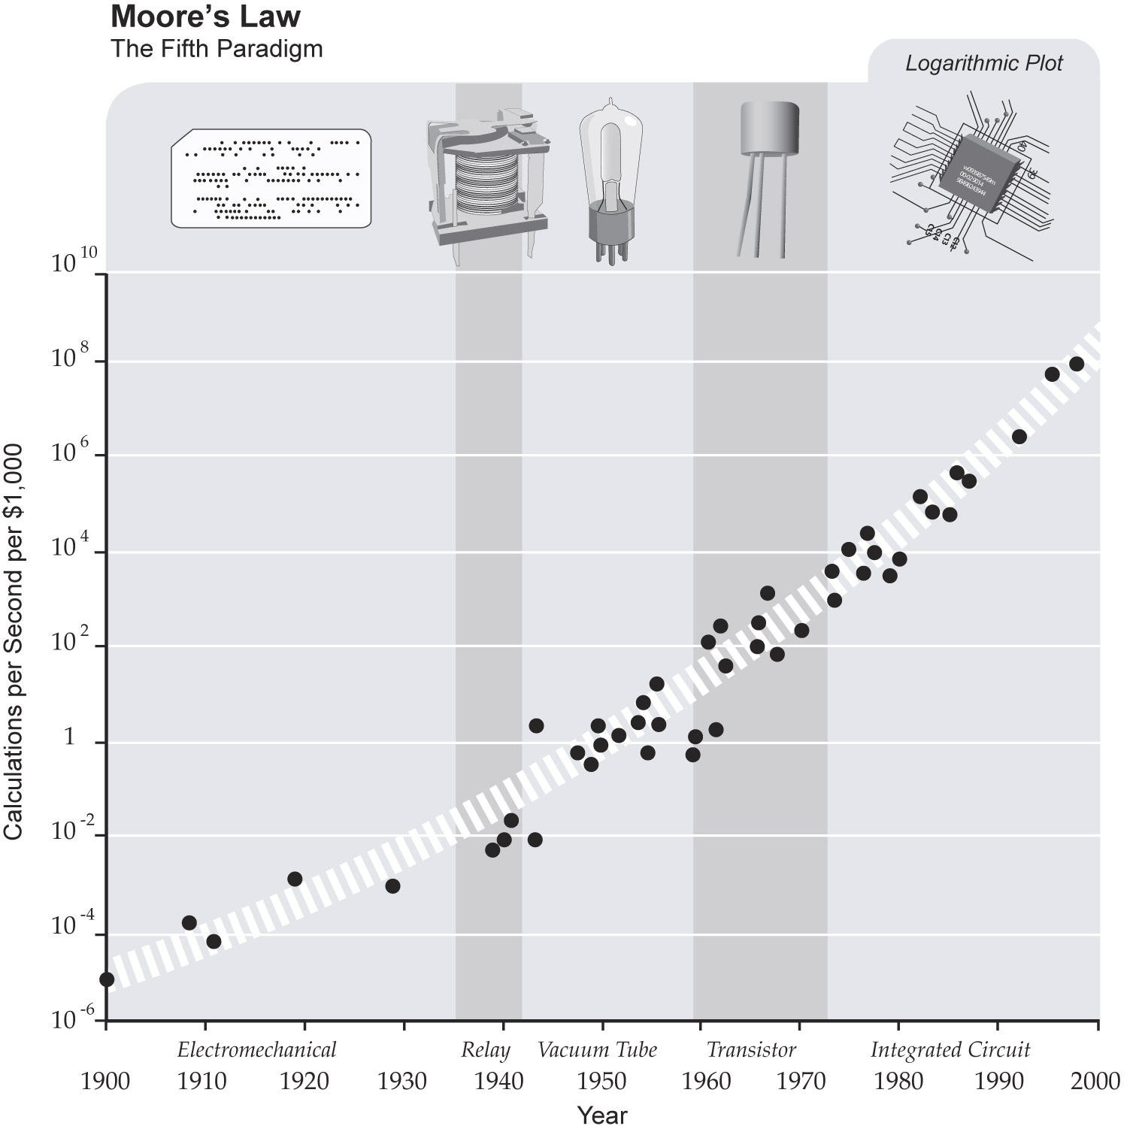
2^{n} (where ‘n’ represents the number of years)

Moore’s Law is the foundation for exciting new technological capabilities and much more. While Moore’s Law is the fundamental driver of the semiconductor industry, what’s even more important is what it delivers to the end user. Advances in process technology and reductions in cost make computing devices accessible to an ever-increasing number of people worldwide, empowering innovations across the computing continuum—from the smallest handheld devices to the largest cloud-based servers.

The evidence of Moore’s Law is everywhere, embedded in devices millions of people use every day, such as personal computers and laptops, mobile phones, and common household appliances and consumer electronics—as well as inspiring, important technological innovations in automobiles, life-saving medical devices, spacecraft, and much, much more!.

The ‘Impact’ of Moore’s Law:

The original transistor built by Bell Labs in 1947 was large enough that it was pieced

together by hand. By contrast, more than 100 million 22nm tri-gate transistors could fit onto

the head of a pin.

More than 6 million 22nm tri-gate transistors could fit in the period at the end of this

sentence.

A 22nm tri-gate transistor’s gates that are so small, you could fit more than 4000 of them

across the width of a human hair.

If a typical house shrunk as transistors have, you would not be able to see a house without a

microscope. To see a 22nm feature with the naked eye, you would have to enlarge a chip to

be larger than a house.

Compared to Intel’s first microprocessor, the 4004, introduced in 1971, a 22nm CPU runs

over 4000 times as fast and each transistor uses about 5000 times less energy. The price per

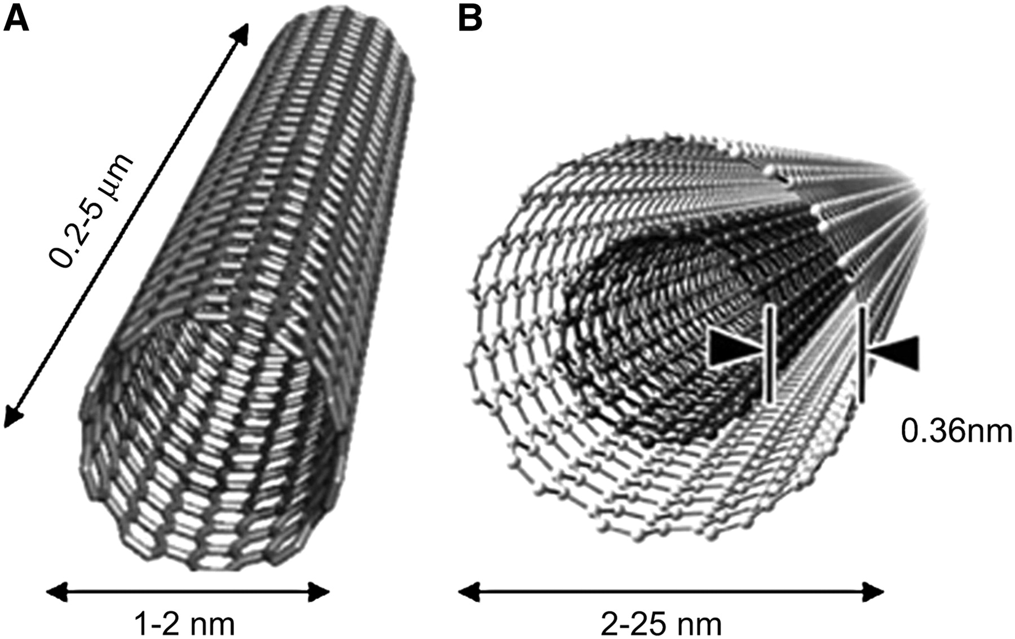
transistor has dropped by a factor of about 50,000.

A 22nm transistor can switch on and off well over 100 billion times in one second. It would

take you around 2000 years to flick a light switch on and off that many times

It’s one thing to design a tri-gate transistor but quite another to get it into high volume

manufacturing. Intel’s factories produce over 5 billion transistors every second. That’s

150,000,000,000,000,000 transistors per year, the equivalent of over 20 million transistors

for every man, woman and child on earth.
- Thus in four years, computers will be 2⁴ or 16 times faster than they are today.
- In the year 2030, one can reasonably expect computers to be 131,072 times faster than they are today! (Given todays computers process around 4 billion instructions per second, the classroom of 2030 should be quite different than todays!)
NanoTechnology meets Computer Hardware
It's getting harder and harder to build transistors with silicon semiconductor channels. One alternative IBM is pursuing are transistor channels made of carbon nanotubes, a lattice of carbon atoms rolled into a tube.

Part 2: Thirty years with computers (Article Review)

Reference: http://www.useit.com/alertbox/20040524.html
http://news.cnet.com/Thirty-years-with-computers/2010-1001_3-5221124.html

I started using computers in 1974, when I was still in high school. My first computer took up an entire room and yet had only five kilobytes of RAM. Punched paper tape was the main form of data input, and the operator console was an electric typewriter. No screens, no cursor. The CPU (central processing unit) ran at a speed of about 0.1MHz. === 100000 I.P.S. compared to 4.25 billion I.P.S.

Despite its primitive nature, this early computer was much more pleasant to use than the monster mainframe I was subjected to a few years later, when I started at the university. The early, simple computer couldn't do much, though I did design a few text-based games for it. Still, it was a single-user computer--basically a PC the size of a room. When you used it, you had total control of the machine and knew everything it did, down to the spinning and whirring of the punched tape.
Although the bigger, newer mainframe had an actual CRT (cathode ray tube) screen, it also had obscure commands and horrible usability. Worst of all, it was highly alienating, because you had no idea what was going on. You'd issue commands, and some time later, you might get the desired result. There was no feeling of mastery of the machine. You were basically a supplicant to a magic oracle functioning beyond the ken of humankind.

People who started using computers after the PC revolution have no idea about the miserable user experience that centralized computers imposed.
People who started using computers after the PC revolution have no idea about the miserable user experience that centralized computers imposed. Even the worst PC designs today feel positively liberating by comparison.

For me, the experience of moving to a small, relatively transparent computer from an oppressively large and opaque one marked the start of my passion for usability. I knew that it could feel good to use computers, and I wanted to recapture that sense of empowerment and put humans back in control of the machines.

For the field in general, it's worth remembering the downsides to centralized computing. We must take steps to keep users in control, as we grow the power of the network. It's essential that we keep a strong front end to balance out improved back-end features.

What 2034 will bring?

If I keep up my exercise schedule, I stand a good chance of experiencing computers 30 years from now. According to Moore's Law, computer power doubles every 18 months, meaning that computers will be a million times more powerful by 2034. According to Nielsen's Law of Internet bandwidth, connectivity to the home grows by 50 percent per year; by 2034, we'll have 200,000 times more bandwidth. That same year, I'll own a computer that runs at 3PHz CPU speed, has a petabyte (a thousand terabytes) of memory, half an exabyte (a billion gigabytes) of hard disk-equivalent storage and connects to the Internet with a bandwidth of a quarter terabit (a trillion binary digits) per second.

The specifics may vary: Instead of following current Moore's Law trajectories to speed up a single CPU, it's likely that we'll see multiprocessors, smart dust and other ways of getting the equivalent power through a more advanced computer architecture. But users shouldn't have to care about such implementation details.

By 2034, we'll finally get decent computer displays, with a resolution of about 20,000 by 10,000 pixels.
By 2034, we'll finally get decent computer displays, with a resolution of about 20,000 pixels by 10,000 pixels (as opposed to the miserly 2,048 pixels by 1,536 pixels on my current monitor). Although welcomed, my predicted improvement factor of 200 here is relatively small; history shows that display technology has the most dismal improvement curve of any computer technology, except possibly batteries.

How could anyone use petabytes of memory and terabits of bandwidth for personal needs? Hard to imagine now, but I don't think we'll have any trouble putting the coming hardware cornucopia to good use. We'll use half the storage space to index all our information so that we can search it instantly. Good riddance, snoozy Outlook search.

We'll also spend a big percentage of the computer power on defense mechanisms such as self-healing software (to root out bugs and adapt to changing environments) and aggressively defensive virus antibodies. We'll need such software to protect against "social engineering" attacks, such as e-mail that purports to come from your boss and asks you to open an attachment.
Computer games in 2034 are likely to offer simulated worlds and interactive storytelling that's more engaging than linear presentations such as those in most movies today. For this new entertainment, the simplest accomplishment we need is artificial actors rendered in real time in high-definition animation. Adapting stories to individual users will be much harder. Once solved, the resulting user interfaces will be much more appealing to a broad market than current computer games, which typically feature convoluted game play and simplified worlds.

Even without full artificial intelligence, computers will exhibit more signs of agency and work to defend their owner's online interests rather than sitting passively, waiting for commands. Richer interaction styles are also likely, both in terms of gestures, physical interfaces, multidevice interfaces and the long-awaited decent high-resolution flat screen.

Certainly, our personal computer will remember anything we've ever seen or done online. A complete HDTV record of every waking hour of your life will consume 2 percent of your hard disk.
Science fiction authors do a better job than I do of speculating on future advances and the implications for human existence. However, one thing is certain: The transition from punched tape to the Web and megapixel displays is merely the first and smallest part of the evolution of user interfaces. If we keep human needs in mind and harness the increased computer power appropriately, there will be great and exciting things ahead in our field.

Part 3: Why take Engineering?
The fattest knight at King Arthur's round table was Sir Cumference. He acquired his size from too much pi.
  Best Jobs in North America
  1. | Software engineer
  2. | College professor
  3. | Financial advisor
  4. | Human resources manager
  5. | Physician assistant
  6. | Market research analyst
  7. | Computer/IT analyst
  8. | Real estate appraiser
  9. | Pharmacist
  10. | Psychologist
  Occupations with the Most New Jobs: Bachelor's Degrees
  2002-2012
  1. | Elementary school teachers, except special education
  2. | Accountants and auditors
  3. | Computer systems analysts
  4. | Secondary school teachers, except special and vocational education
  5. | Computer software engineers, applications
  6. | Special education teachers
  7. | Computer software engineers, systems software
  8. | Network systems and data communications analysts
  9. | Network and computer systems administrators
  10. | Computer programmers
  Ten Fastest Growing Occupations for College Grads
  2004-2014
  1. | Network systems and data communications analysts
  2. | Physician assistants
  3. | Computer software engineers, applications
  4. | Physical therapist assistants
  5. | Dental hygienists
  6. | Computer software engineers, systems software
  7. | Network and computer systems administrators
  8. | Database administrators
  9. | Physical therapists
  10. | Forensic science technicians
  Fastest-Growing Professional Jobs
  2002-2012
  1. | Environmental engineers
  2. | Network systems and datacom analysts
  3. | Personal financial advisors
  4. | Database administrators
  5. | Software engineers
  6. | Emergency management specialists
  7. | Biomedical engineers
  8. | PR specialists
  9. | Computer and infosystems managers
  10. | Comp, benefits, and job analysts
  11. | Systems analysts
  12. | Network and systems administrators
  13. | Training and development specialists
  14. | Medical scientists
  15. | Marketing and sales managers
  16. | Computer specialists
Part 4: Exercises:

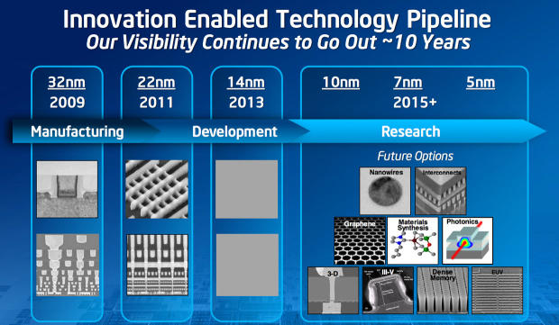

Question 1
What does Moore's law say?
- The number of transistors which can fit on a chip doubles every 18-24 months.
- The number of platters in a hard drive doubles every 18-24 months.
- The speed of a transistor in gigahertz doubles every 18-24 months.
- The number of texts sent by a student doubles every 18-24 months.
Question 2
Which one of the following is a result of Moore's law?
- Computers get more expensive over time
- Computers emit more ionizing radiation over time
- Computers get smaller and cheaper over time
- Computers get physically larger over time

Question 3
Which one of the following hardware components provides persistent storage (i.e. maintained when the power is off)?
- Hard Drive b) CPU c) RAM d) Heat Sink

Question 4
Which one of the following hardware components is the active "brain" doing the computation in the computer?
a) CPU b) RAM c) Hard Drive d) Heat Sink

Question 5
Which one of the following hardware components provides temporary byte storage during a computation, but is erased when the power is turned off?
a) Hard Drive b) RAM c) CPU d) Heat Sink
Using a search engine, answer the following:

- Name 4 engineering programs offered at the following sites:

Mohawk
College

Sheridan
College

Conestoga
College

McMaster University

Waterloo
University

Queens
University

Guelph
University

- Using a search engine find out who said the following quotes:

“…We need young people, instead of -- a smart kid coming out of school, instead of wanting to be an investment banker, we need them to decide if they want to be an engineer, they want to be a scientist, they want to be a doctor or a teacher,"

ANSWER: ____________________________Source: _____________________________________

"My friends tease me about being a computer geek but it's not really an insult anymore,"

ANSWER: _____________________________Source: _____________________________________

"For everything from your cellphone to GPS to the system that helps fly your airplane — somebody wrote that code,"

ANSWER: ___________________________ Source: _____________________________________

Reference:

Which engineering program is for you?
https://www.youtube.com/watch?v=5pYJ9-cj69Y

Is engineering right for me?
https://www.youtube.com/watch?v=vj-H_Mbfvu4

What is bio-medical engineering?
https://www.youtube.com/watch?v=kIY5PKAft-o

How much math is in engineering?
https://www.youtube.com/watch?v=hIN0o7moYrQ

McMaster university engineering
https://www.youtube.com/watch?v=H_XbVHh2oq4

University of Guelph biomedical engineering
https://www.youtube.com/watch?v=6APUOcQW_i8

Stick man engineering
https://www.youtube.com/watch?v=qx9lLiAISAw

What is engineering?
https://www.youtube.com/watch?v=bipTWWHya8A

Should you know how to code?
https://www.youtube.com/watch?v=axltjnTyHOc

Genetic Engineering
https://www.youtube.com/watch?v=jAhjPd4uNFY

