TEJ101 Computer Engineering
Name: | Activity 0 – Course Outline

Welcome!
Hello TEJ101 Computer Engineering student and welcome to room 220 at BR. My name is __________________ and I will be your engineering teacher. You have made a very wise decision in selecting this course, and from my perspective, you should consider yourself very fortunate as you are in one of the most HIGH-TECH engineering labs you will find anywhere! This lab is “jam-packed” with exciting engineering technologies ... we have state-of-the-art DELL computers running Windows 7, a CNC machine, a laser cutter, a 3D printer, scanners, tools, electronics and tons of robots!

In this course you will go beyond the novice or beginner levels of computer use. You will have the opportunity to work with robotics, and animation. Along the way you will investigate the CNC machine, the 3D printer and work with the laser engraver.

You will also have the opportunity to learn and explore some of the new technologies such as mobile devices, wireless technologies and some of the new high-tech skills and concepts. We will be investigating the Specialized High Skills Major now being offered at Bishop Reding in Computer Engineering and see where it fits into your career path.

What is Engineering in Room 220?

The concept of engineering has existed since ancient times as humans devised fundamental inventions such as the pulley, lever, and wheel. Each of these inventions is consistent with the modern definition of engineering, exploiting basic mathematical and scientific principles to develop and create useful objects. We have the same goal in this room and this course ... to employ math and science to INVENT useful tools and objects. You will be inventing through the use of computer programming, mechatronics, and design engineering. For example, you will be asked to make a robot travel an exact distance. This requires a knowledge of kinematics (circumference, radius, PI) etc. You will be measuring many things ... some with a ruler .. some with a micrometer and some with the pixels on a screen ...all of which require the use of numbers.. hence the need for good numeracy skills. Another task is to write the code to create a computer game. This task needs organization, accuracy and the application of physics to objects that are used in your game...again more numeracy and science skills.

Computer programming has become as important in the engineering world today as reading and writing. It seems like everywhere I look I see another application of computer programming ... take for example, the Nike foot sensor that transmits bio-medical data to an I-device because some engineer wrote the code for the sensor and device to talk...or the

Ipod shuffle that can store over 2000 songs because some engineer wrote an operating system for the hardware in it and created an interface for easy consumer use. We see these kinds of things everyday. This course will give you a ‘taste’ of computer programming.

One of the most widely used tools in the engineering profession is computer-aided design (CAD) software which enables engineers to create 3D models, 2D drawings, and schematics of their designs. CAD allows engineers to create models of designs that can be analyzed without having to make expensive and time-consuming physical prototypes. This course will give you a ‘taste’ of computer aided design.

How are you evaluated?

Course Evaluation:
Your mark will be calculated using the following categories:

- Knowledge/Understanding/ Thinking /Inquiry 50%

Various small programming assignments. Quizzes, Robotics challenges etc

- Communication 10%

This component of your mark is based on many forms of communication. For example, your clarity on answering questions, your explanation of a concept, your notebook organization and clarity of notes are all part of the communication portion of your final mark.

- Application 20%

This component is based on how you apply the concepts and skills while working on assignments. There are many practical assignments in this course and you will be evaluated on the process you go through in the completion of those assignments.

- WRITTEN EXAM – written during exam week 20%

Room 220 Expectations:

As previously stated, this is a very advanced engineering lab. Please exercise good manners and judgement AT ALL TIMES. As such, I have the following expectations of students using this rooms equipment and before continuing in this course, students MUST BE aware of them.

Punctuality - Being on time.

Punctuality in this course means sitting in your desk, prepared with the proper academic tools needed, (pen, pencil, notebook) when the bell rings. (It does not mean running into room 221 while the bell is ringing). Students are expected to be on time to class. You must be seated in this class by _____________ or you will be considered late.
Students are NOT ALLOWED
to bring any
FOOD or DRINKS
To ROOM 220
What to do if you are Late

WAIT QUIETLY outside my door and DO NOT DISTURB MY CLASS or ANY OTHER CLASS. When I am ready I will come and discuss your punctuality.

At 3 Lates ... You will PHONE HOME and inform your parent(s) and the vice-principal of your punctuality problems. A consequence will be given.
At 4 Lates ... same as above
At 5 Lates ... You will PHONE HOME again and inform your parent(s) of the punctuality problem and I will pass you over to the Vice Principal where escalated consequences will be given.

Uniform

Students must be in complete uniform or have received permission from the vice-principal in order to attend class. The uniform code is specified on the schools web site and I will administer the policy . Out of uniform...out of class.

Responsible Use of Computers and Technology in the Room

Handle all equipment WITH CARE. This includes mice, screens, sensors, motors, wheels, etc.

Gaming Do not goto gaming websites - your computer privileges will be suspended. DO not play games of any type during the class.

Email NOT ALLOWED. Under certain circumstances the teacher may approve your request o use email. For this you must ask first.

Internet Use Visiting websites other than those prescribed for the course by the teacher are NOT ALLOWED. Your computer privileges will be suspended.

Appropriate Use of Robotic & Computer Technology

Do not touch another students piece of work whether it is a robot, a part of a robot, a computer, monitor, mouse, printout, etc without the CONSENT of the teacher and the student it belongs to. I WILL NOT TOLERATE INAPPROPRIATE BEHAVIOUR. Your computer/technology privileges will be suspended and you will be dealt with by the vice principals. Common sense and appropriate behaviour must be maintained at all times.

Check your Computer
Always check your workstation at the start of class. If you spot damage, report it immediately. DO NOT REMOVE ANY CABLES FROM THE COMPUTER

Missed Work
It is your responsibility to catch up on any work missed due to illness or school-related activity.

Cheating Policy
If you share / copy / paste etc. your work, all parties involved will receive a zero!

Saving Your Work
All work must be saved on the ‘H’ drive. Work done on other drive letters will not be marked. You are responsible for all of your files.

LOST NOTES:
If you leave your assignment notes behind, either on the desk or at the computer, they will be lost. The replacement cost is $0.25 per page.

Weekly Schedule:

Monday | Test day
Tuesday | Lesson with application
Wednesday | Lesson with application
Thursday | Lesson with application
Friday | Application & presentations,

ATTITUDE IS EVERYTHING!

PATHWAY PLANNER FOR
University Engineering & Computer Science Destinations
ICT SHSM – BISHOP REDING

 | GRADE 9 | GRADE 10 | GRADE 11 | GRADE 12
1 | Religion  HRE10 | Religion  HRE2O | Religion  HRT3M | Religion  HRE4M
2 | English  ENG1D | English  ENG2D | English  ENG3U | English  ENG4U
3 | Math  MPM1D | Math  MPM2D | Functions  MCR3U | Calculus & Vectors  MCV4U
4 | Geography  CGC1D | History  CHC2D | Advanced Functions  MHF4U | SPARE
5 | Science  SNC1D | Science  SNC2D | Chemistry  SCH3U | Chemistry  SCH4U
6 | Phys. Ed Credit | Art Credit | Physics  SPH3U | Physics  SPH4U
7 | Computer Engineering  TEJ1O | Computer Engineering  TEJ3M | Computer Engineering  TEJ4M | Co-op
8 | French  FSF1D | Computer Programming  ICS3U | Computer Programming  ICS4U | Co-op
CONT  ED |  | Civics/Careers  CHV2O/GLC2O

The CHV2O/GLC2O credit will focus on preparing SHSM students for their pathways and placement experiences.
Students need to check which of the Grade 11 and 12 math and science courses are required for the type of Engineering they are planning to pursue. For example, students may wish to take Biology in grade 11 and 12 should they be interested in a Biotechnology post-secondary pathway. See http://www.electronicinfo.ca

This is what it looks like!
Will your name be next?

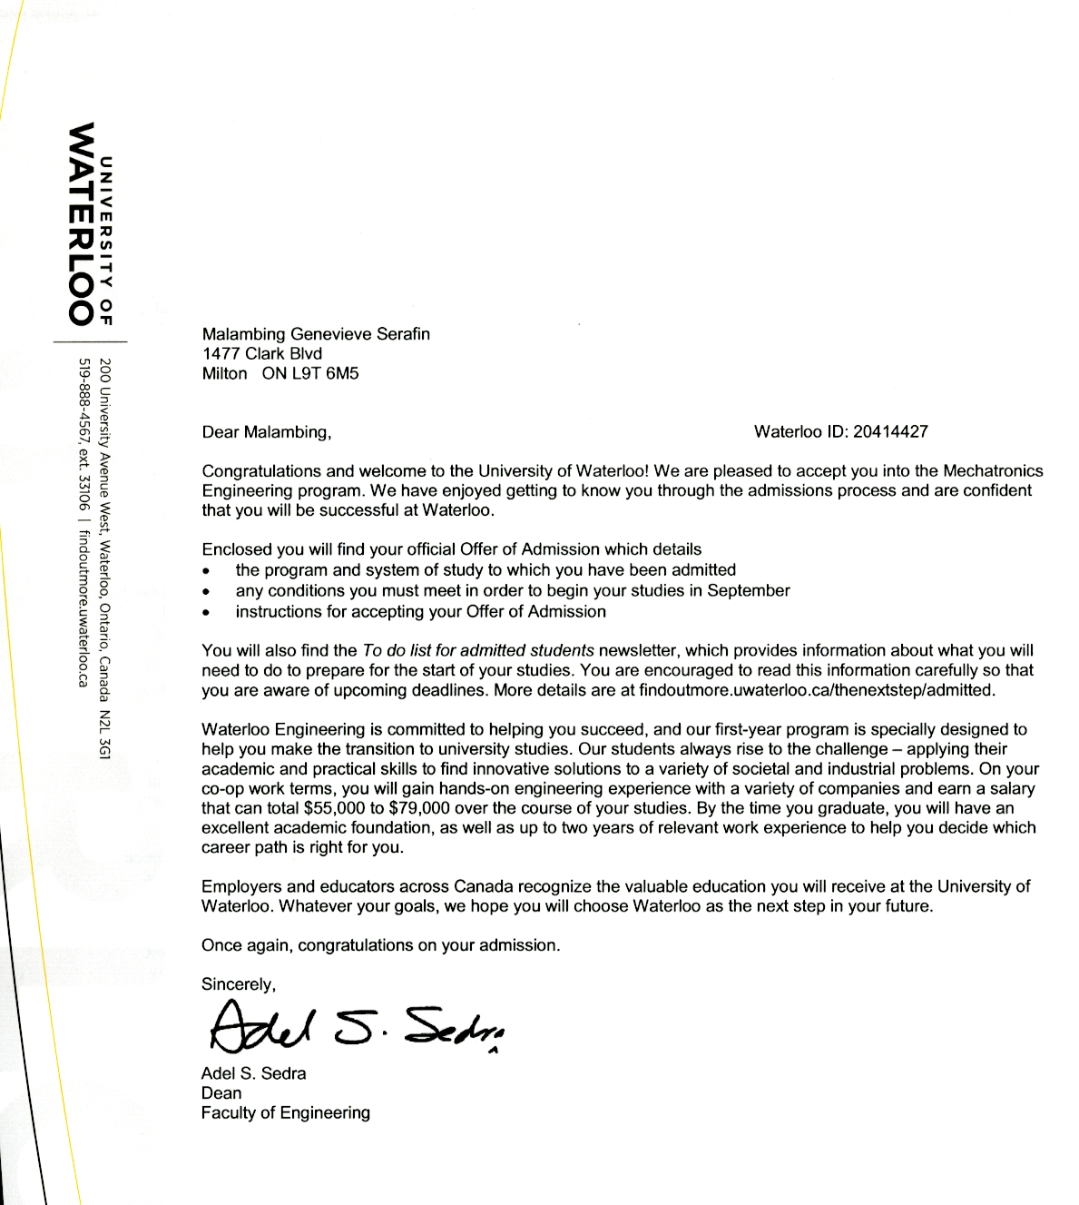

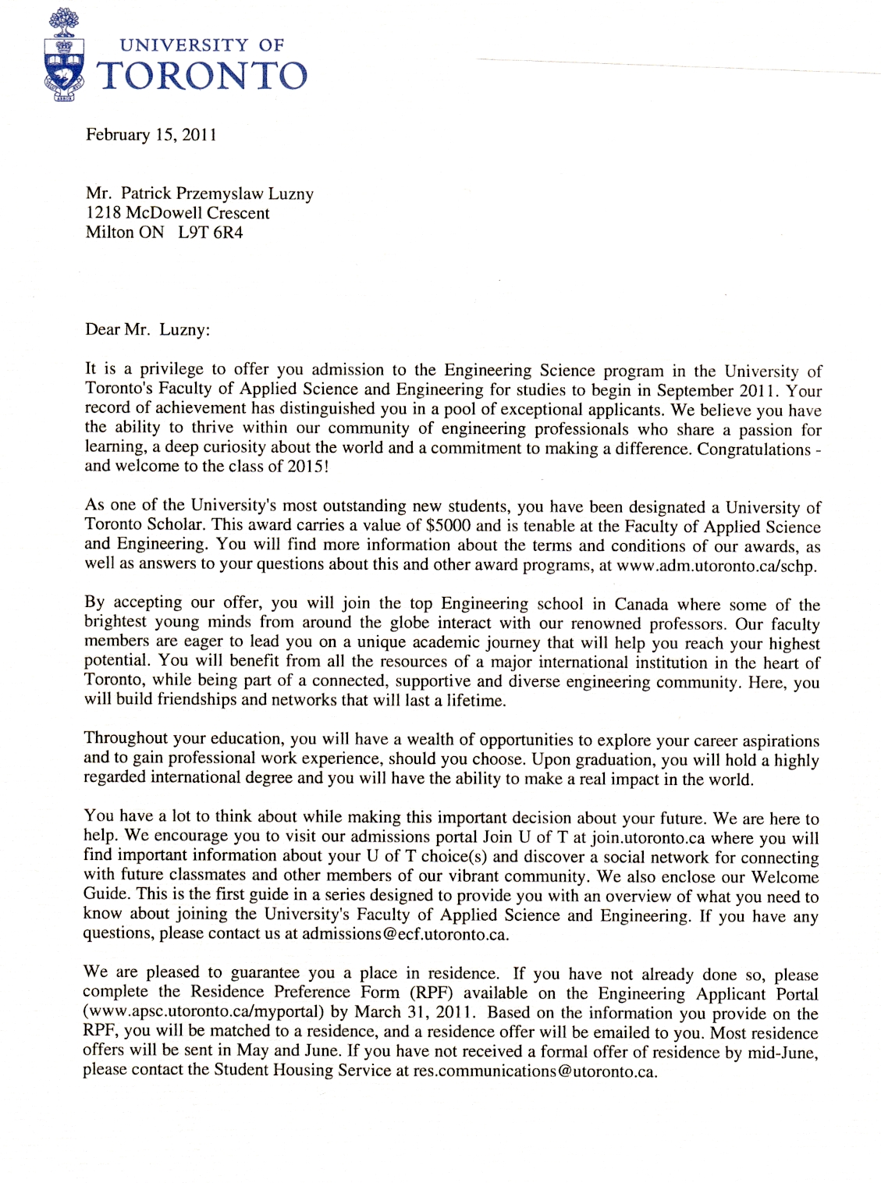
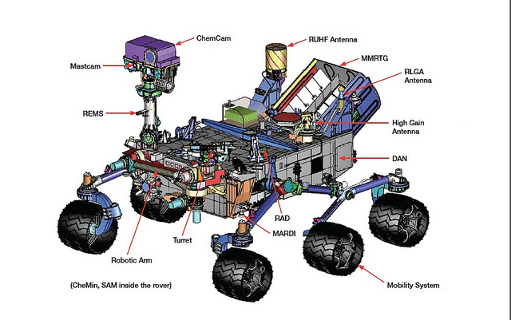
Have a great semester !

